

SQL: CHINOOK MUSIC PROJECT

By:- Amar

Professional Data Science and AI Course Sept-2025 at Newton School.

**Objective Questions**

**1. Does any table have missing values or duplicates? If yes, how would you handle it?**

Answer :- To keep our data reliable and complete, I needed to find and deal with any missing information (NULLs) in our database tables. Here's how I went about identifying and handling these gaps across the different tables.

**Step 1 : Checking for NULL Values**

I reviewed all the tables from data set one by one for any null values across all columns then I found out customer table, employee table and track table containing null values. The following SQL query was used to identify rows where any of the columns might contain a null value:

**For Customer Table:**

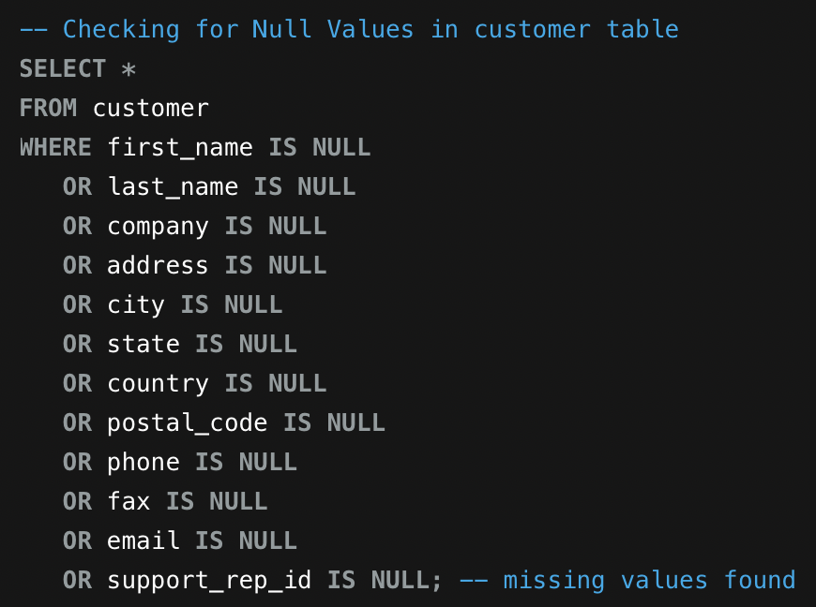

**For Employee Table:**

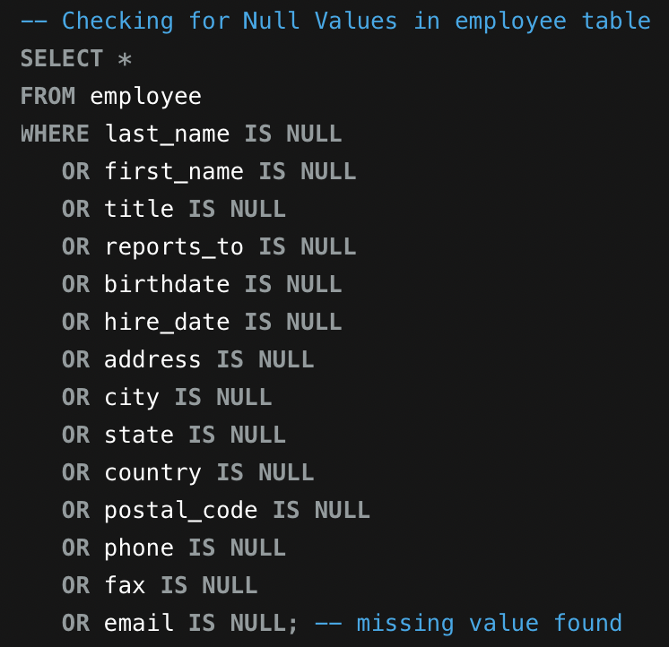

**For Track Table:**

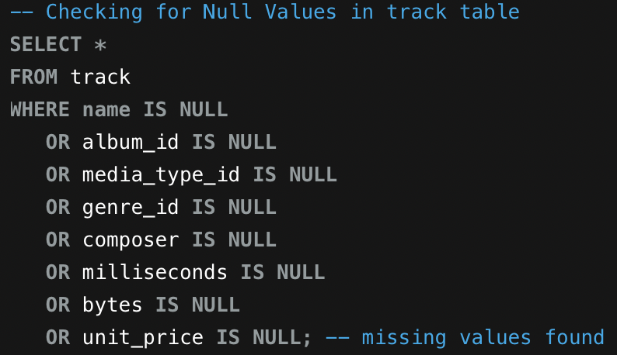

**Step 2 : Handling NULL Values**

I went through the database and filled in missing information to keep everything clean and prevent errors during analysis.

**What I did:**

First, I turned off SQL's safe update mode so I could make bulk changes across the tables.

Then I replaced the missing values with sensible defaults:

* **Customer table**: Filled in 'Unknown' for missing companies, 'None' for states, '+0 000 000 0000' for blank phone/fax numbers, and '0' for postal codes
* **Employee table**: Set '0' for employees who don't report to anyone (probably the top bosses)
* **Track table**: Added 'Unknown' for tracks with no composer listed

This way, there are no blank spots left in the data, and the placeholder values are easy to spot if I need to revisit them later.

Here is snapshot you can see what I did for execution :

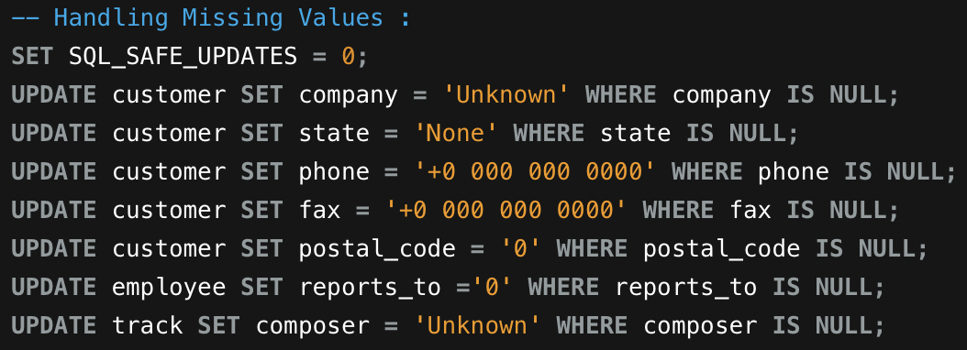

**OUTPUT TABLES BELOW :-**

Customer Table :

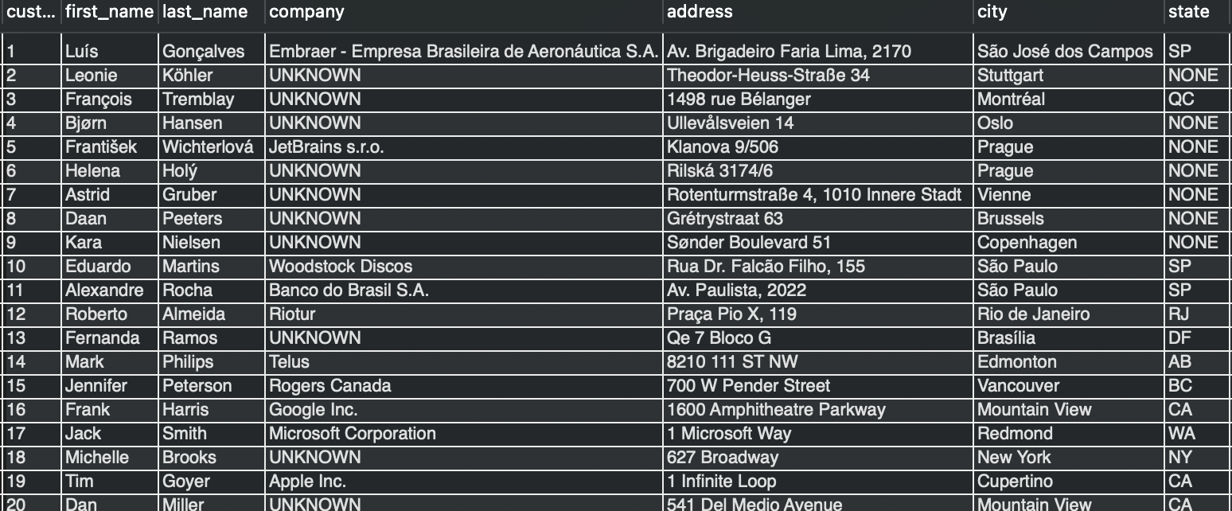

Employee Table :

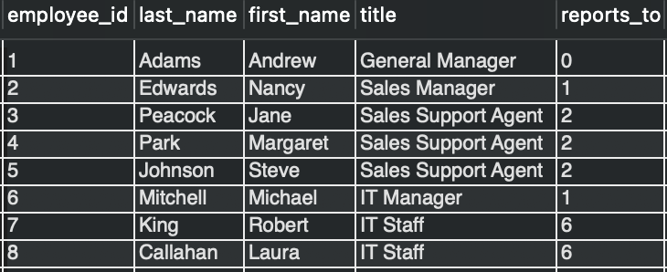

Track Table :

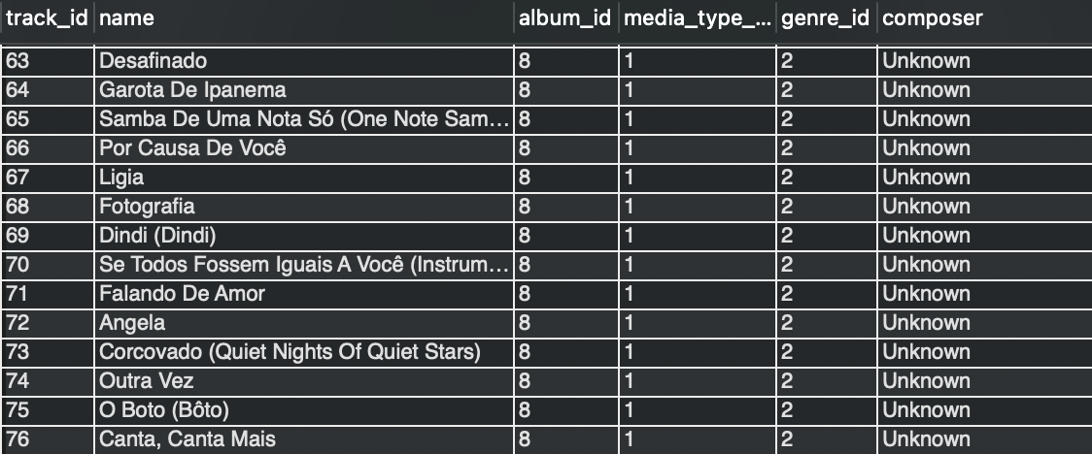

**Step 3 : Checking and Handling Duplicate Values**

To ensure data quality, I checked all tables for duplicate records. I used a GROUP BY query to identify any rows that appeared more than once based on their key attributes.

**Method Used:**

For each table, I grouped records by their primary identifying columns and counted occurrences. For example, in the album table:

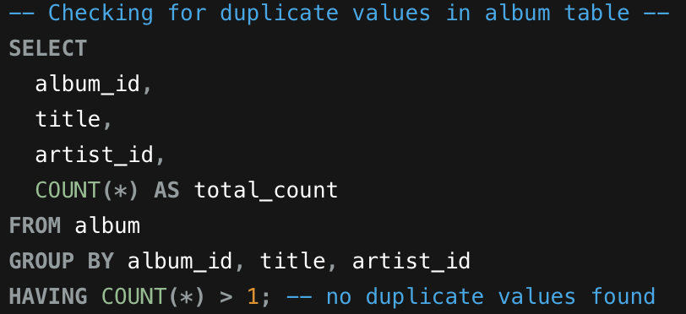

I applied this same approach across all tables in the database, checking for duplicates based on each table's relevant columns.

After running these checks on every table, I found **no duplicate records**. This confirms that the database maintains proper data integrity with unique entries throughout.

**2. Find the top-selling tracks and top artist in the USA and identify their most famous genres.**

Answer :-

We have to find three results :

1. Top-selling track in USA.

2. Top-artist in USA

3. Famous Genres in USA.

**Approach :**

For this I have taken tables are as follows :

invoice table, customer table, track table, album table, artist table and genre table and used the joins to join them to find the three results mentioned.

**1 :- Top-selling track in USA:**

**Query for the Analysis:**

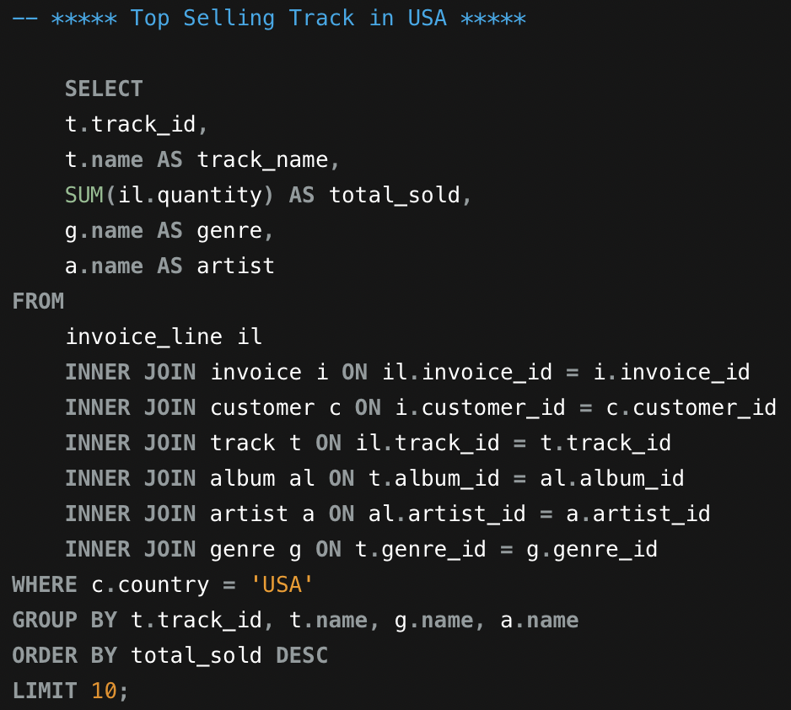

**Output Table:**

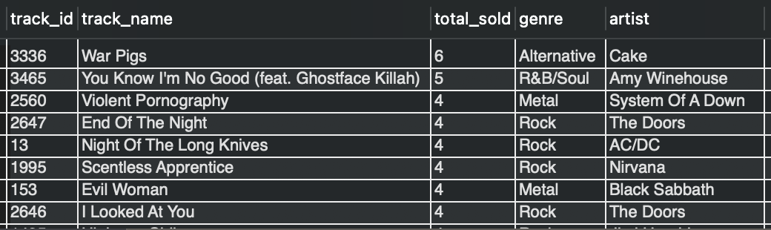

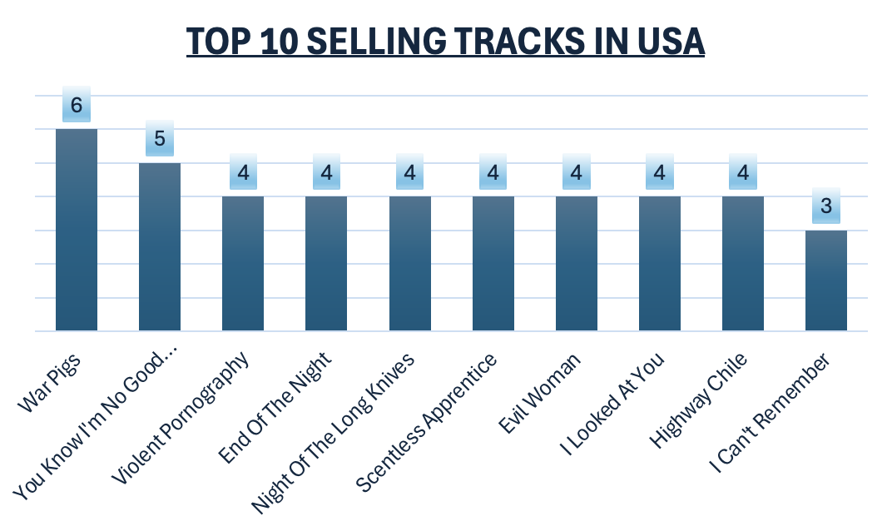

**Insights:**

**Top Selling Tracks:**

* "War Pigs" by Cake and "You Know I'm No Good" with Ghostface Killah by Amy Winehouse are the biggest hits, selling 6 and 5 copies each.

**Genres Distribution:**

* Rock dominates the sales, with hits like "End Of The Night" by The Doors, "Night Of The Long Knives" by AC/DC, and others leading the pack.

**Popular Artists:**

* The Doors and Nirvana are fan favorites, with songs like "End Of The Night" and "I Looked At You" selling well. Other popular names include Nirvana, Black Sabbath, and Jimi Hendrix.

**Variety of Music:**

* The bestsellers cover different styles - Rock, Alternative, Metal, and R&B/Soul - showing that customers have diverse tastes.

**Sales Distribution:**

* Sales vary quite a bit across different songs. Some sold as few as 3 copies (like "I Can't Remember" by Alice In Chains), while the top seller "War Pigs" by Cake hit 6 copies.

These insights give us a quick look at what's popular, what genres people prefer, and which artists are resonating with customers.

**2 :- Top Artist in USA and Most Famous Genres of the Top Artist:**

**Query for the Analysis:**

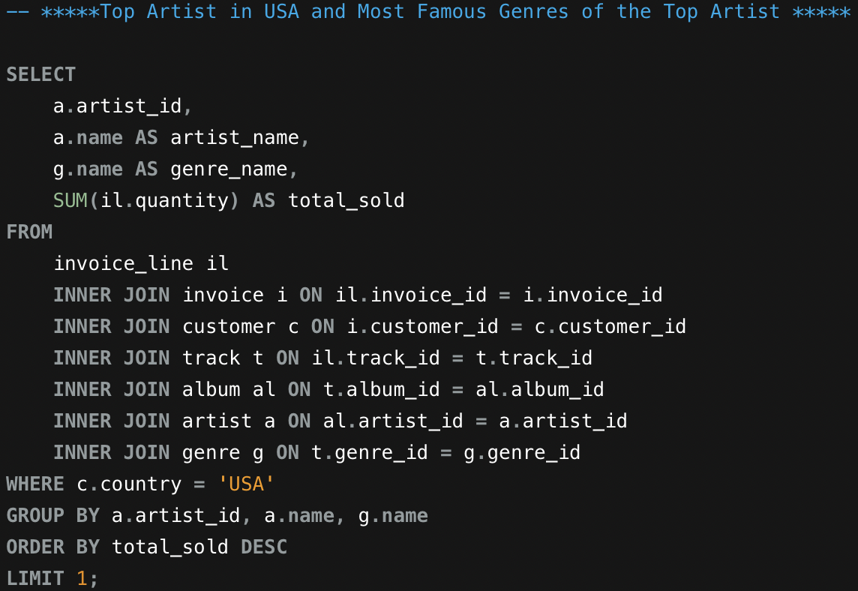

**Output Table:**

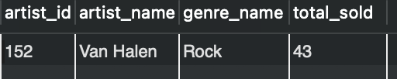

**Insights:**

The data indicates that **Van Halen** is a leading artist in the United States, reflecting significant popularity and robust sales figures. With a total of **43 units sold**, the group demonstrates a substantial and sustained fan base as well as lasting musical impact. Furthermore, the predominant genre associated with this artist is Rock, underscoring the genre’s prominent role and influence within the music industry. These findings suggest that Rock music maintains a loyal audience, which has contributed to Van Halen’s continued success.

**3. What is the customer demographic breakdown (age, gender, location) of Chinook's customer base?**

Answer :-

**Approach:**

The CTE were used to retrieve the total number of customers country wise and city wise, using aggregation concept.

**Query for the Analysis:**

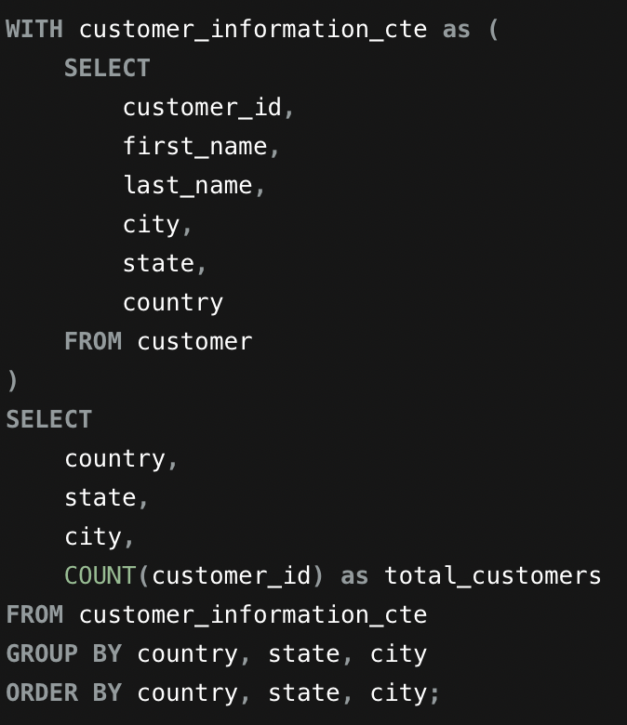

**Output Table:**

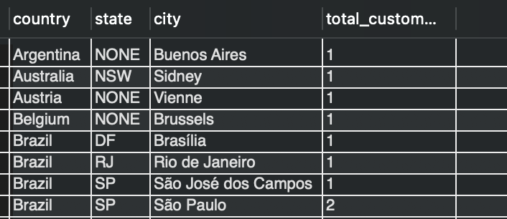

**Visualisation**:

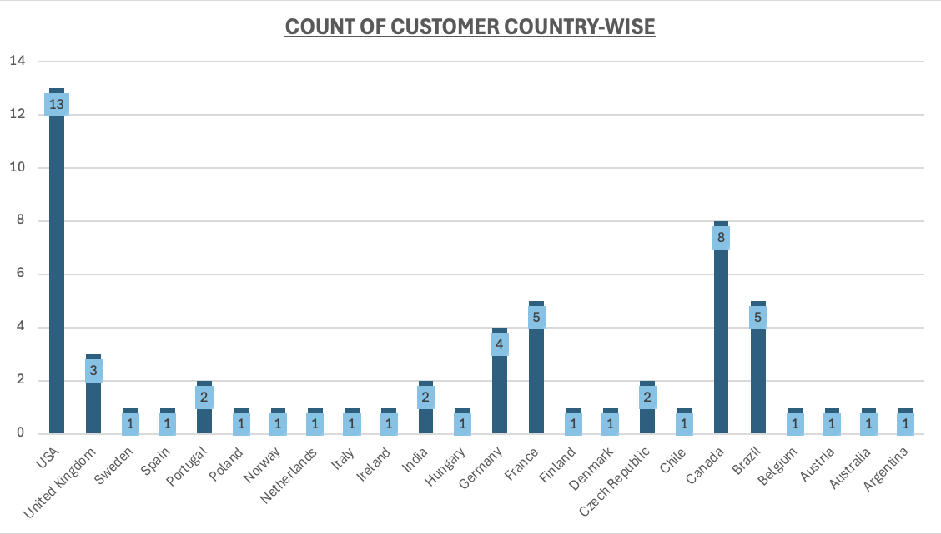

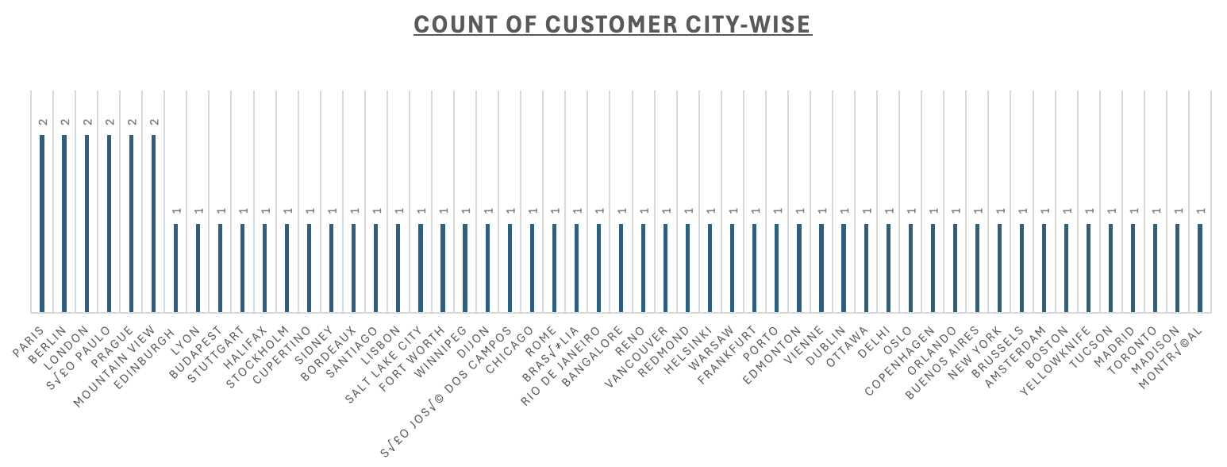

**Insights:**

* **Top Cities for Customers:** São Paulo (Brazil), Paris (France), and London (UK) are tied for first place - each city has 2 customers.
* **Brazil's Strong Showing:** Brazil pops up several times on the list, with São Paulo leading the way. The company clearly has a solid foothold in Brazil.
* **The USA is All Over the Map:** American customers are spread across different cities. Mountain View and New York both have 2 customers each, showing the US presence is widespread rather than concentrated in one spot.
* **Single-Customer Cities:** Most countries only have one city represented, which means the customer base is pretty thin in those places compared to the bigger cities.
* **Major Cities Win:** There's a clear pattern here - major cities and capital cities like Paris, London, and New York have more customers. It makes sense - the bigger and more well-known the city, the more customers you'll find there.

**NOTE:**- There is no data for age and gender.

**4. Calculate the total revenue and number of invoices for each country, state, and city:**

Answer :-

**Approach:**

* I used the invoice table for its sales totals and location data since it contains all information.
* Invoices were grouped by country, state, and city.
* I calculated total revenue (SUM(total)) and invoice count (COUNT(invoice_id)).
* Then sorted results by revenue to identify Chinook’s top-performing regions.

**Query for the Analysis:**

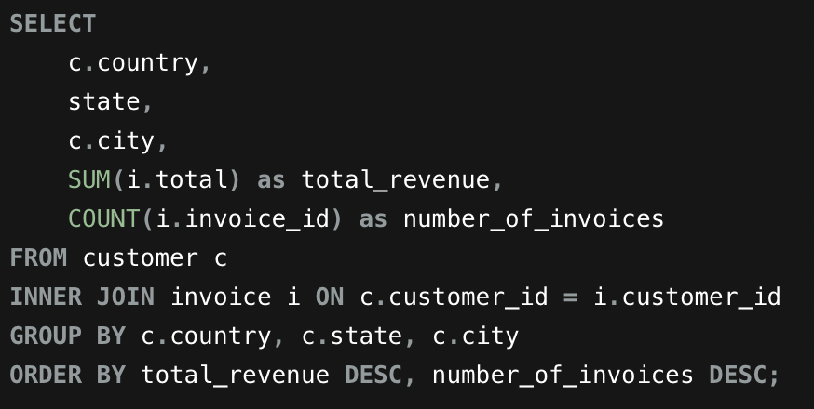

**Output Table:**

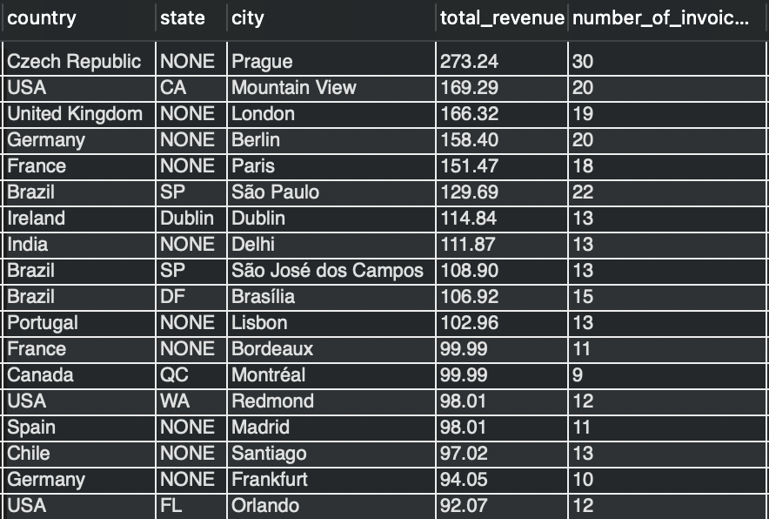

**Insights:**

* **Prague** in the Czech Republic takes the crown for most purchases - **30** in total! And they're also making good money at **$273.24**. Clearly, business is booming there.
* **Paris ($151.47) and London ($166.32)** are pulling in some serious revenue. They've got lots of transactions happening, and people there might be spending more per purchase too.
* **São Paulo, Brazil** brings in **$129.69** in total sales from **22** purchases. That's pretty impressive and shows there's real opportunity in this market.
* **US cities** are doing well across the board. **Mountain View** brings in **$169.29**, while **New York** adds **$79.20**. Different cities, solid results.
* Places like **Canada** and **Australia** have decent sales activity, but the revenue is lower. Basically, people are buying regularly, but they're not spending as much per purchase.

**5. Find the top 5 customers by total revenue in each country.**

Answer :-

**Approach:**

**Step 1: Calculate Customer-Wise Revenue :** Using CTE customer_wise_revenue

* **Purpose:** Aggregate total revenue for each customer.
* **Actions:**
  + Join customer and invoice tables using customer_id.
  + Combine first and last names into a single customer name field..
  + Calculate total revenue by summing all invoice amounts per customer.
  + Group results by customer ID, name, and country..
  + Sort by country and revenue for organized output.

**Step 2: Rank Customers Within Each Country:** Using CTE ranked_customers

* **Purpose:** Assign rankings to customers based on their spending within their respective countries
* **Actions:**
  + Use the RANK() window function to rank customers.
  + Partition data by country (so ranking restarts for each country)..
  + Order by total revenue in descending order (highest spenders get rank 1).
  + Include all customer details and their calculated rank.

**Step 3: Filter Top 5 Customers per Country**

* **Final SELECT Statement**
* **Purpose:** Extract only the top performers from each country.
* **Actions:**
  + Filter results to show only customers with rank 5 or better.
  + Display customer ID, name, country, revenue, and rank.
  + Sort final output by country first, then by rank for easy reading.

**Query for the Analysis:**

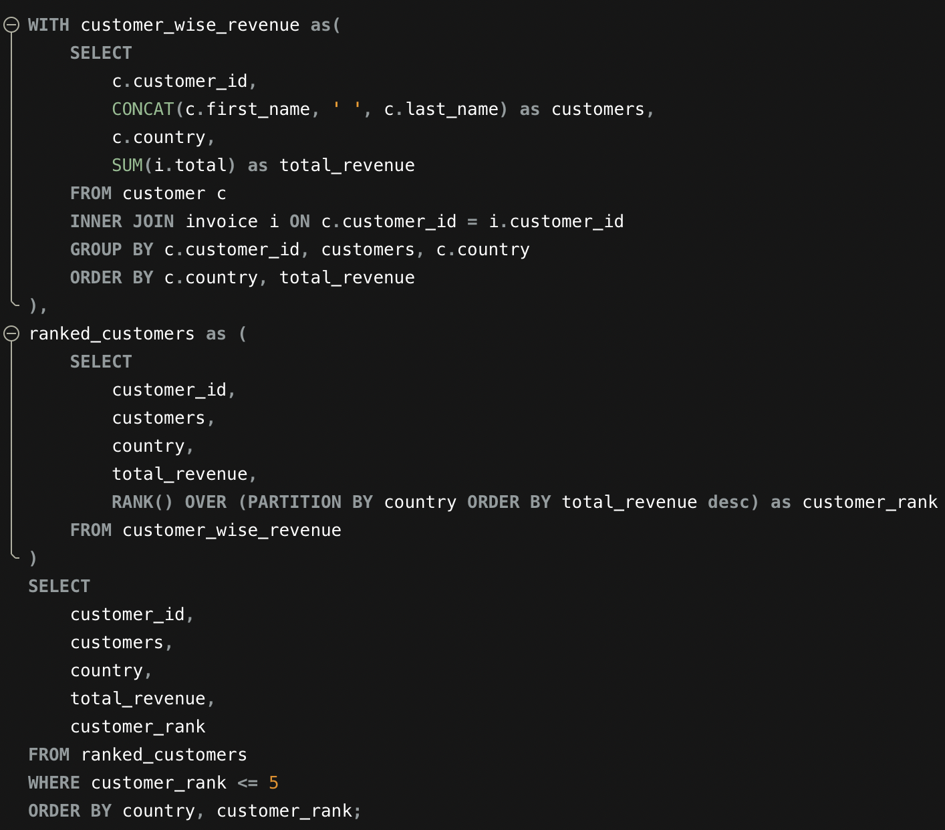

**Output Table:**

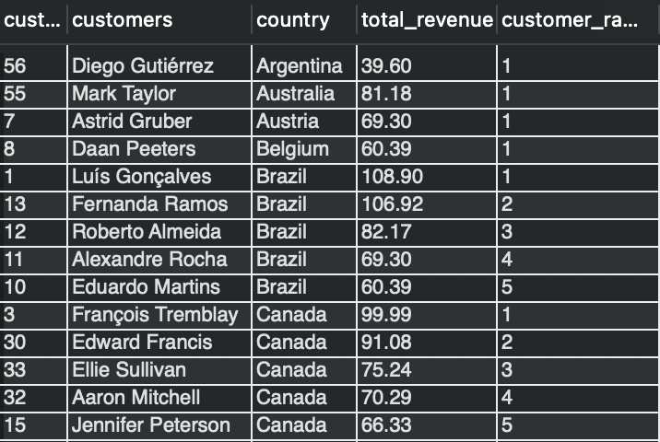

**Visualisation:**

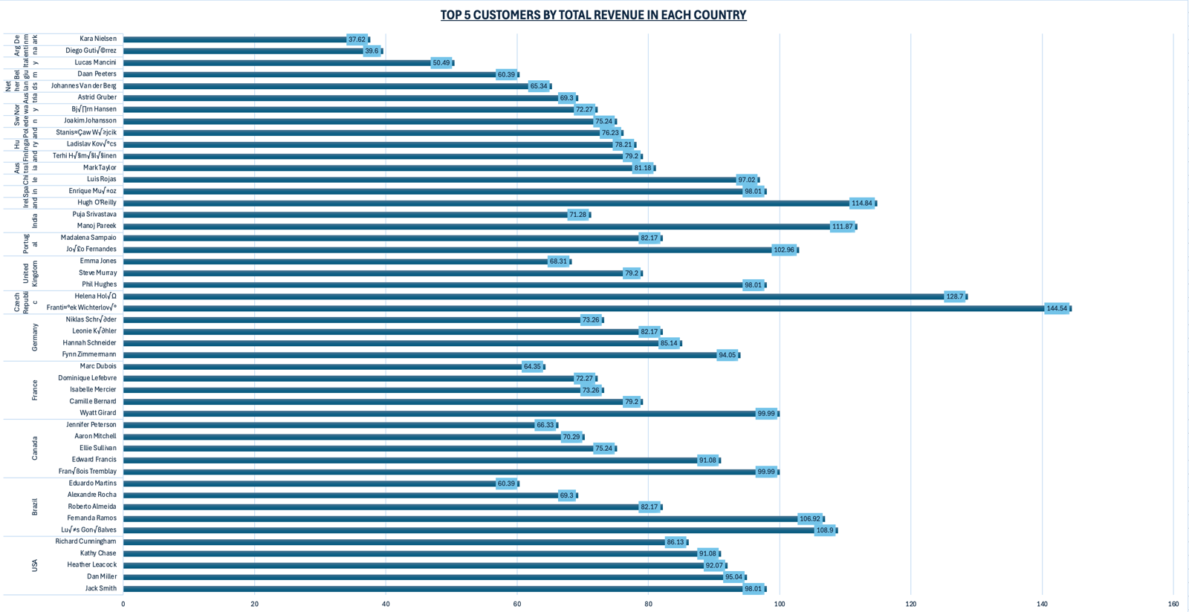

**Insights:**

* **Top Spender:** František Wichterlová from Czech Republic leads with $144.54 - showing great customer value potential there.
* **Global Winners:** Brazil, India, Ireland, and Portugal all have customers spending over $100 - strong sales across different parts of the world.
* **Loyal Customer Base:** Countries like Brazil, Canada, and Germany have multiple customers on the list, meaning they've got solid, repeat business.
* **Steady Global Performance:** Most customers spend between $60-$100, showing consistent sales no matter where they're located.
* **Standout Stars:** A few customers really shine - like Manoj Pareek in India ($111.87) and Hugh O'Reilly in Ireland ($114.84) - proving some markets have exceptional individual buyers.

**6. Identify the top-selling track for each customer.**

Answer :-

**Approach:**

* **Find total purchases by each customer**: First, we join the customer, invoice, and invoice_line tables to collect all the tracks purchased by each customer.  
  We then calculate the **total quantity of tracks purchased** by every customer.
* **Link customers with the tracks they purchased**: Next, we join this customer-level data again with the invoice, invoice_line, and track tables to identify **which tracks were purchased by each customer**.
* **Rank tracks for each customer**: Using a ranking function, we rank the tracks **separately for each customer** based on their total purchase quantity, with the most purchased track ranked first.
* **Select the top-selling track**: We filter the data to keep only the **top-ranked track (rank = 1)** for each customer.  
  This gives us the **most purchased track for every customer**.
* **Sort the final result**: Finally, we order the output by total quantity purchased in descending order to clearly see customers with higher purchase volumes.

**Query for the Analysis:**

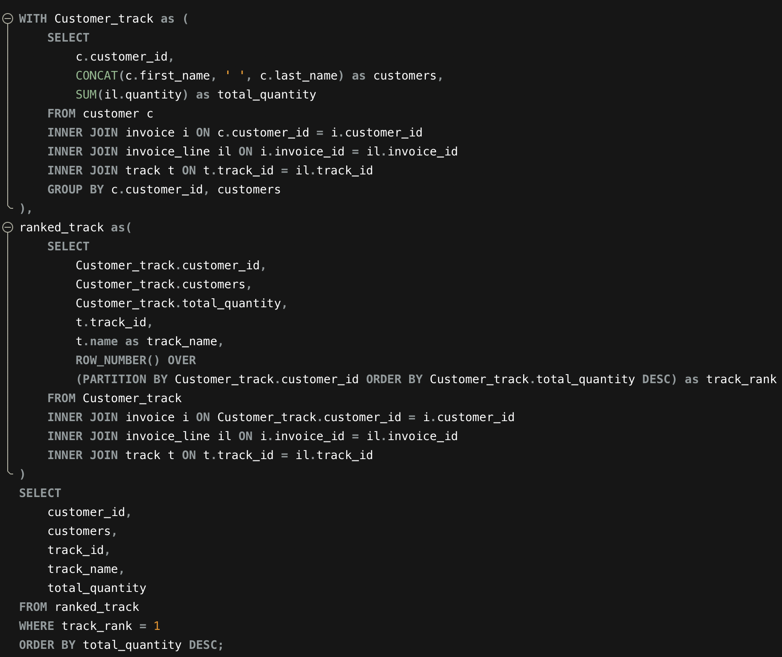

**Output Table:**

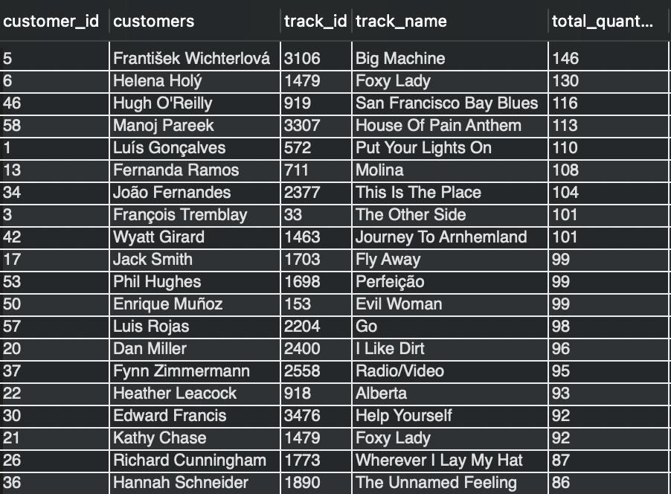

**Visualisation:**

* For Clarity took only top 10 customers for visualisation.

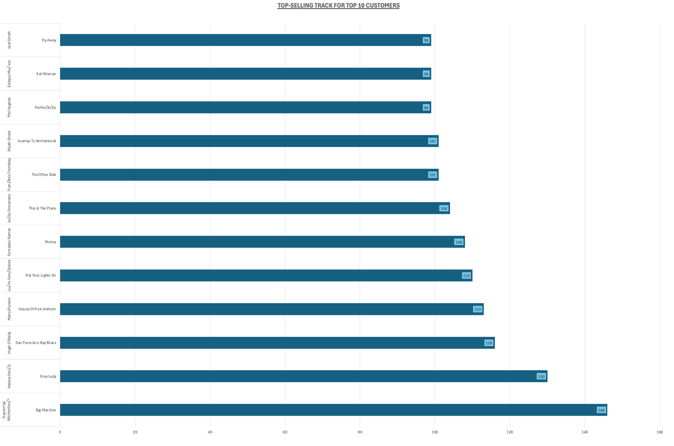

**Insights:**

* **Top Tracks:** "Big Machine", "Foxy Lady", and "House Of Pain Anthem" are customer favorites with over 100 units sold each.
* **Customer Loyalty:** Many customers repeatedly purchase their favorite tracks in high quantities, showing strong preference patterns.
* **Diverse Preferences:** Wide variety of tracks purchased across the customer base reflects varied musical tastes.
* **Cross-Customer Appeal:** Popular tracks like "Foxy Lady" attract multiple customers, indicating universal appeal..
* **Global Demand:** High purchase volumes appear across different countries, demonstrating worldwide market strength.

**7. Are there any patterns or trends in customer purchasing behaviour (e.g., frequency of purchases, preferred payment methods, average order value)?**

Answer :-

Since my dataset doesn’t have payment methods, so, I only need to focus on :

* Frequency of Purchases (how many times each customer buys)
* Order Value (how much money they spend per order, on average.

**Frequency of Purchase**

**Query for the Analysis:**

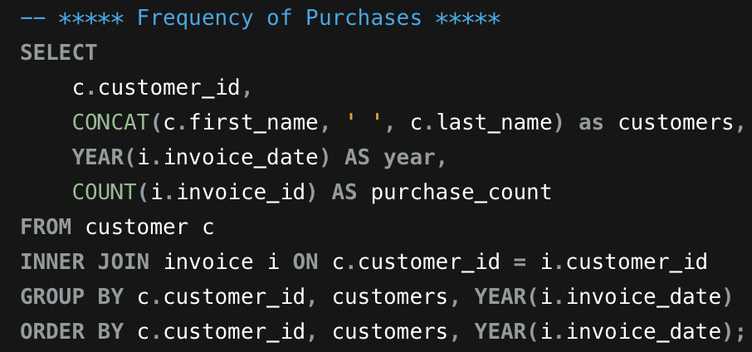

**Output Table:**

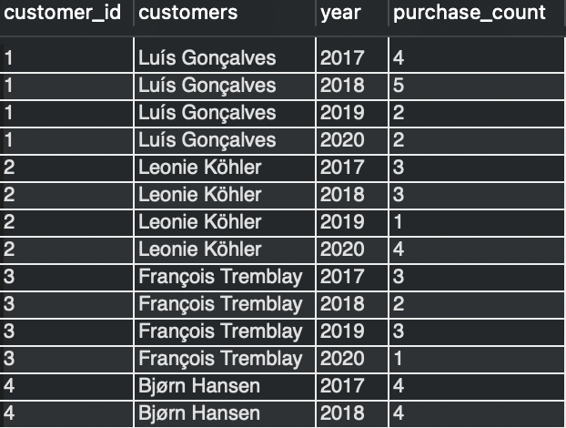

**Visualisation:**

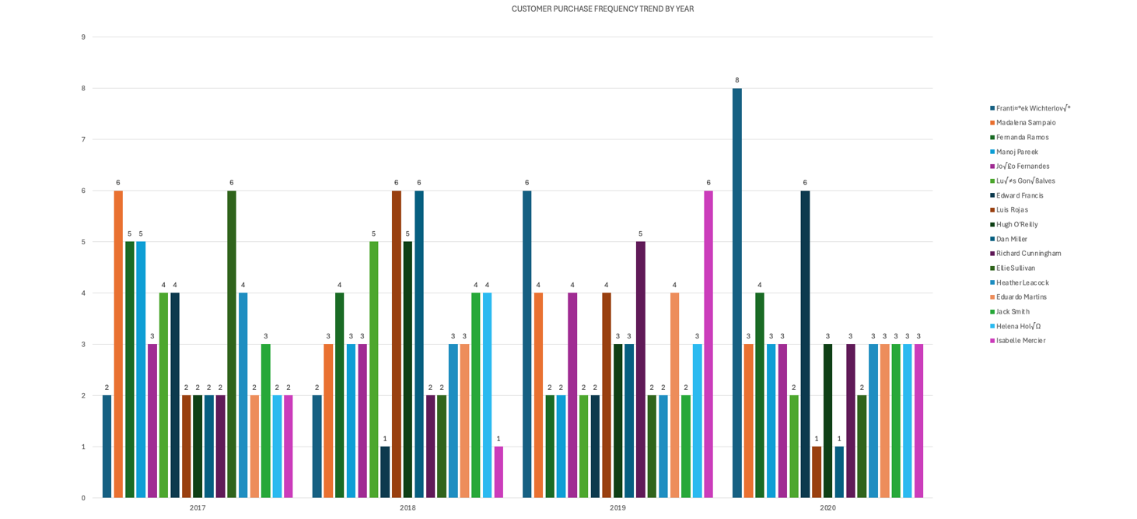

**Insights:**

* **František Wichterlová** showed remarkable growth from 2 purchases in 2017 to 8 in 2020, demonstrating increasing customer engagement over time.
* Customers like **Luís Gonçalves** and **Fernanda Ramos** displayed inconsistent purchasing across years, suggesting irregular buying habits.
* **Hugh O'Reilly** and **Edward Francis** maintained relatively stable purchase counts with minor fluctuations throughout the period.
* Mixed results in 2020 with some customers increasing and others decreasing purchases, likely influenced by external market conditions..
* Notable high-activity periods include **Martha Silk** with 6 purchases in 2017 and **Edward Francis** with 6 purchases in 2020, highlighting strong individual engagement in specific years.

**Calculate the average order value for each customer**

**Query for the Analysis**

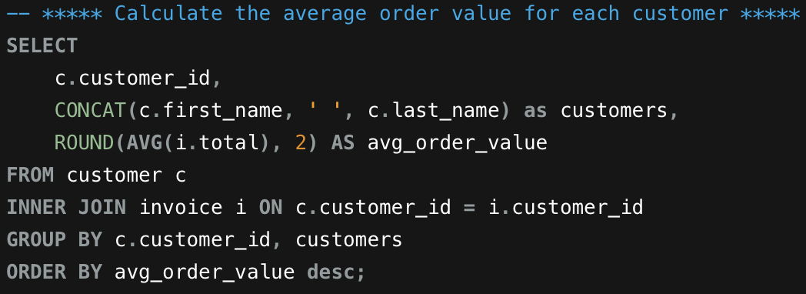

**Output Table:**

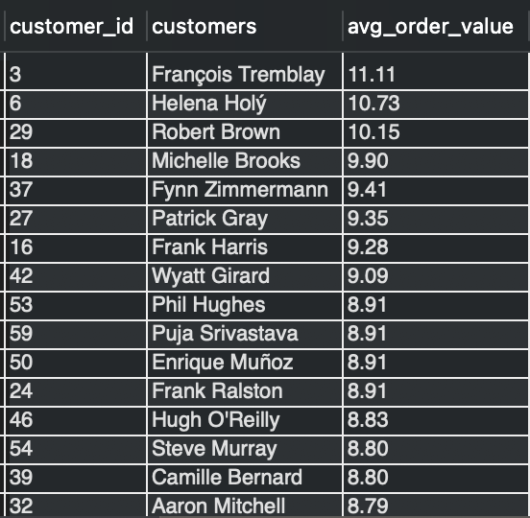

**Visualisation:**

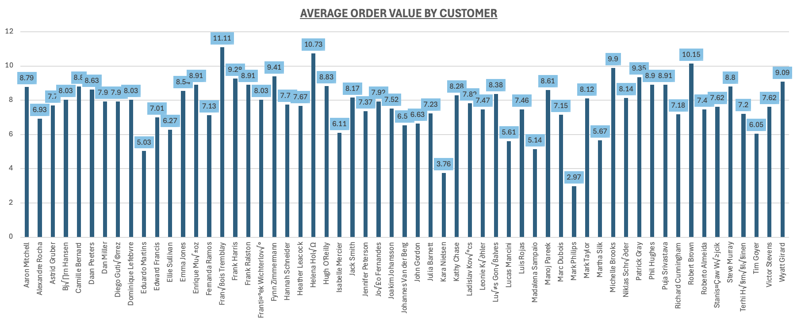

**Insights:**

* **Top Spenders Per Order:** François Tremblay leads with the highest average order value of $11.11, followed by Helena Holý and Robert Brown.
* **Typical Spending Range:** Majority of customers spend between $7-$9 per order on average, representing the standard purchase pattern.
* **Lower Spend Customers:** Kara Nielsen and Mark Philips show the lowest average order values, indicating smaller transaction sizes or selective purchasing.
* **Above-Average Buyers:** Customers like Michelle Brooks and Fynn Zimmermann maintain higher average spending around $9 per order, demonstrating stronger per-transaction value.

**8. What is the customer churn rate?**

Answer :-

**Approach:**

* Identified the **latest invoice date** in the dataset to serve as the reference point.
* Classify **active customers** as those who made at least one purchase in the **last 3 months** from the latest invoice date.
* Identify **churned customers** as customers who have historical purchases but **no purchases in the last 3 months**.
* Calculate the **total number of customers** and the **number of churned customers**.
* Compute the **churn rate percentage** using the formula:  
  **Churn Rate** = (Number of customers lost during a period / Number of customers at the start of the period) x 100

**Query for the Analysis:**

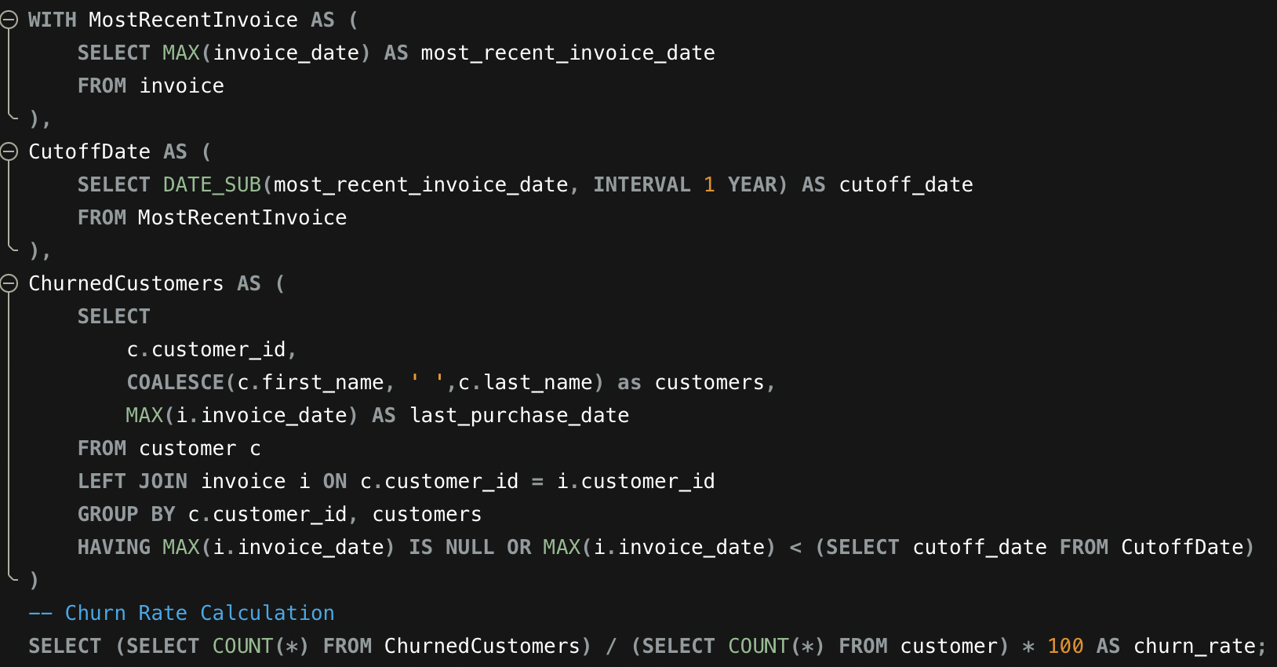

**Output Table:**

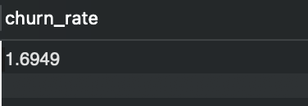

**Insights:**

* The churn rate of **1.7% is very low**, indicating **strong customer retention**.
* Most customers remain **actively engaged** with the platform.
* Chinook’s music offerings effectively **meet customer preferences**.
* The business can focus more on **growth and monetization** rather than retention recovery.
* Continuous churn tracking will help **maintain long-term stability**.

**9. Calculate the percentage of total sales contributed by each genre in the USA and identify the best-selling genres and artists.**

Answer :-

**Approach:**

* Filtered dataset to include **USA** customers only.
* Built a **CTE** called **genre_sales** to sum up total revenue for each music genre..
* Created a second CTE called **artist_sales** to break down revenue by individual artists within each genre..
* Calculated what **percentage** each genre contributes to overall US sales.
* Identified the **top-performing artist** in every genre based on who generated the most revenue.

**Query for the Analysis:**

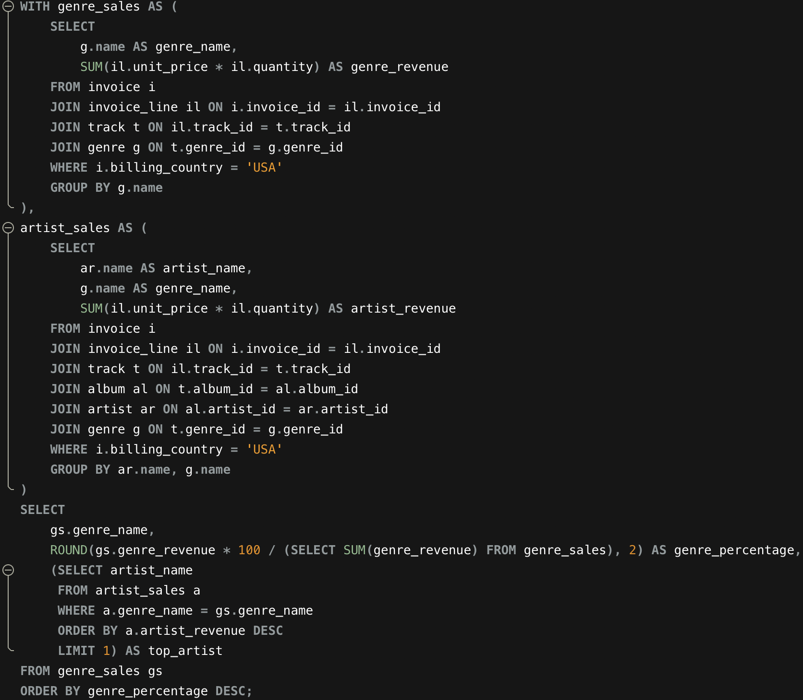

**Output Table:**

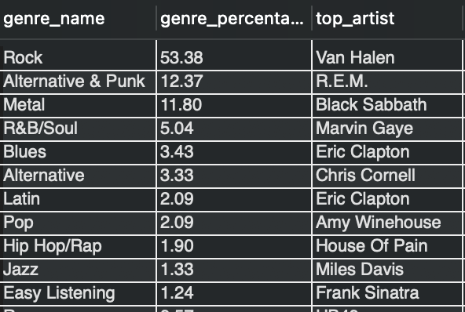

**Visualisation:**

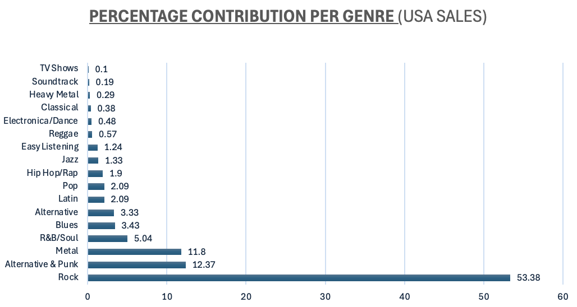

**Insights:**

**Genre Performance:**

* Rock dominates the US music market, accounting for more than half of all sales (53%).
* Alternative & Punk and Metal tie for second place, each representing 12% of total sales.
* Rock clearly leads as the best-selling genre, with Alternative & Punk and Metal following behind.

**Top Artists:**

The five highest-revenue artists in the USA are: Van Halen, Green Day, Black Sabbath, Marvin Gaye, Eric Clapton.

**Market Dynamics:**

* Over half of US music revenue comes from Rock alone.
* The remaining market share is distributed among other genres, with Alternative & Punk and Metal being the most significant contributors after Rock.

**10. Find customers who have purchased tracks from at least 3 different genres.**

Answer :-

**Approach:**

* Joined customer table with invoices to link customers to their purchases.
* Connected invoice line items to get individual track purchases.
* Linked tracks to their corresponding genres through the track and genre tables..
* Combined customer first and last names into a single field for easier readability.
* Counted the number of distinct genres each customer has purchased from.
* Grouped results by customer to calculate metrics at the customer level.
* Applied a filter to show only customers who have purchased from 3 or more different genres.
* Sorted customers by genre count in descending order to highlight the most diverse listeners first.

**Query for the Analysis:**

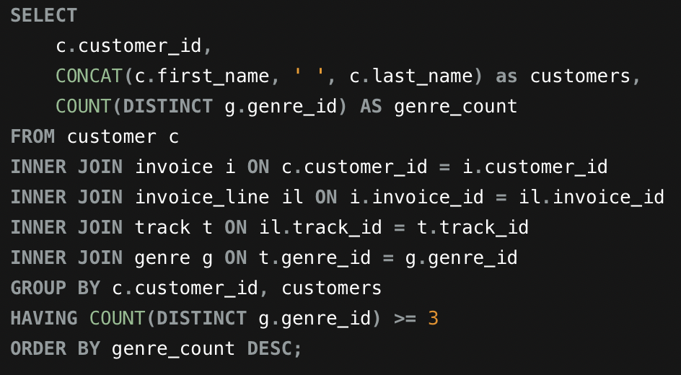

**Output Table:**

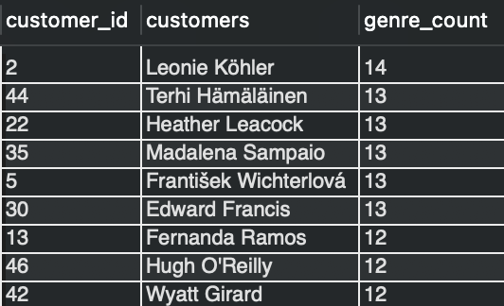

**Insights:**

* **Leonie Köhler** stands out as the most versatile listener, exploring music across **14 different genres**, which reflects a very broad musical interest.
* Customers such as **František Wichterlová** and **Terhi Hämäläinen** also show strong diversity in their listening habits, engaging with **13 genres each**.
* A large group of customers listen to music from **10 to 12 different genres**, indicating an openness to exploring varied styles rather than sticking to one category.
* In contrast, a smaller set of customers, including **Robert Brown**, focus on only a few genres, suggesting **more specific and niche musical preferences**.

**11.Rank genres based on their sales performance in the USA.**

Answer :-

**Approach:**

* Join **genre, track, invoice_line, invoice, and customer** tables to link genres with sales and customer location.
* Filter records to include **only customers from the USA**.
* Calculate **total sales per genre** using (unit_price × quantity).
* Aggregate sales at the **genre level**.
* Rank genres in **descending order of total sales** using a window function.
* Sort the output to clearly identify **top-performing genres in the USA**.

**Query for the Analysis:**

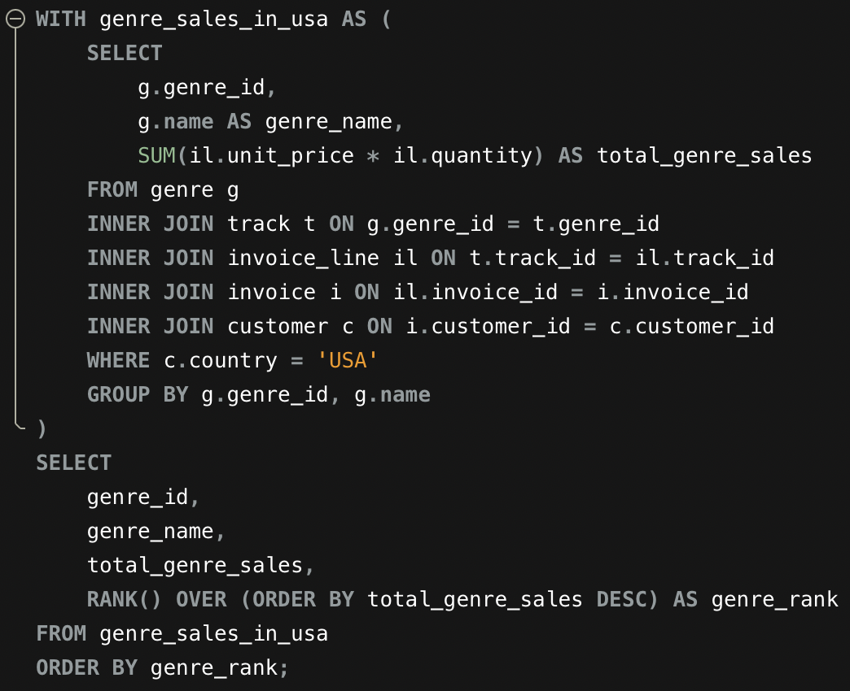

**Output Table:**

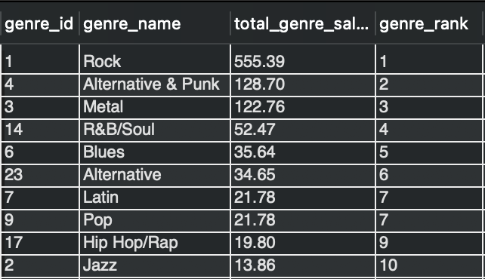

**Visualisation:**

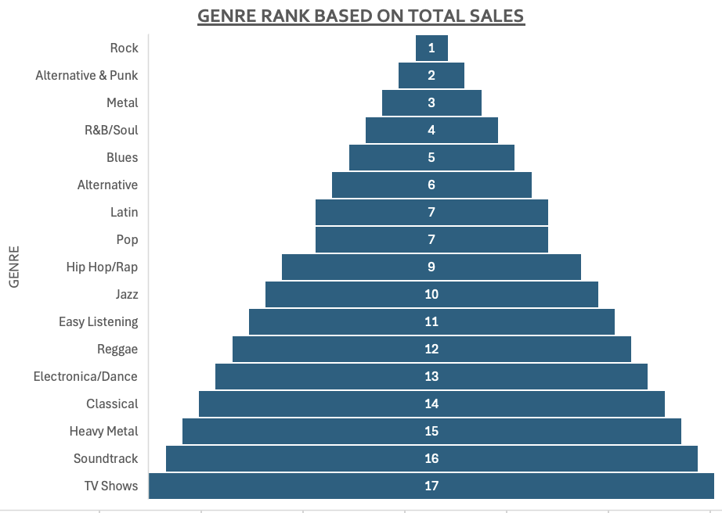

**Insights:**

* Rock clearly dominates with total sales of $555.39, far ahead of any other genre
* This substantial lead confirms Rock's strong appeal across the US customer base.
* Alternative & Punk takes second place with $128.70 in sales.
* Metal secures third position at $122.76.
* R&B/Soul generates moderate revenue at $52.47.
* Blues follows with $35.64 in total sales.

**12. Identify customers who have not made a purchase in the last 3 months.**

Answer :-

**Approach:**

* Use a **LEFT JOIN** between customer and invoice tables to include all customers.
* Calculate each customer’s **most recent purchase date** using MAX(invoice_date).
* Compute **total revenue per customer** by summing invoice totals.
* Group data at the **customer level**.
* Filter customers whose **last purchase was more than 3 months ago** using a HAVING clause.
* Return the list of **inactive customers** along with their last purchase date and total revenue.

**Query for the Analysis:**

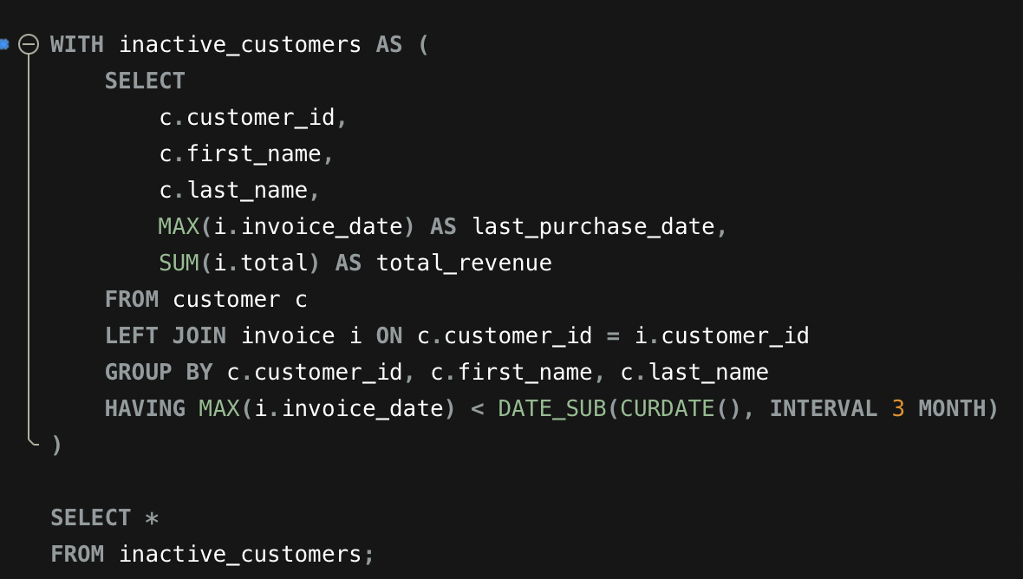

**Output Table:**

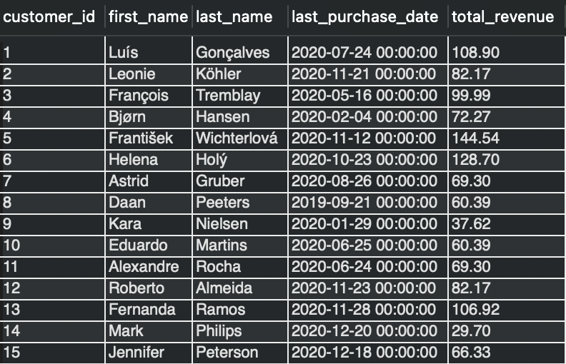

**Insights:**

* The customers in the output table above have not made a purchase in the past 3 months.

**Subjective Questions**

**1. Recommend the three albums from the new record label that should be prioritised for advertising and promotion in the USA based on genre sales analysis.**

Answer :-

**Approach:**

* Considered only **USA customers** to focus on the target market.
* Joined relevant tables to link **albums, genres, and sales transactions**.
* Calculated **total sales revenue** using (unit_price × quantity).
* Aggregated sales at the **album and genre level**.
* Ranked albums by total sales using **DENSE_RANK**.
* Recommended the **top three highest-selling albums** for promotion in the USA.

**Query for the Analysis:**

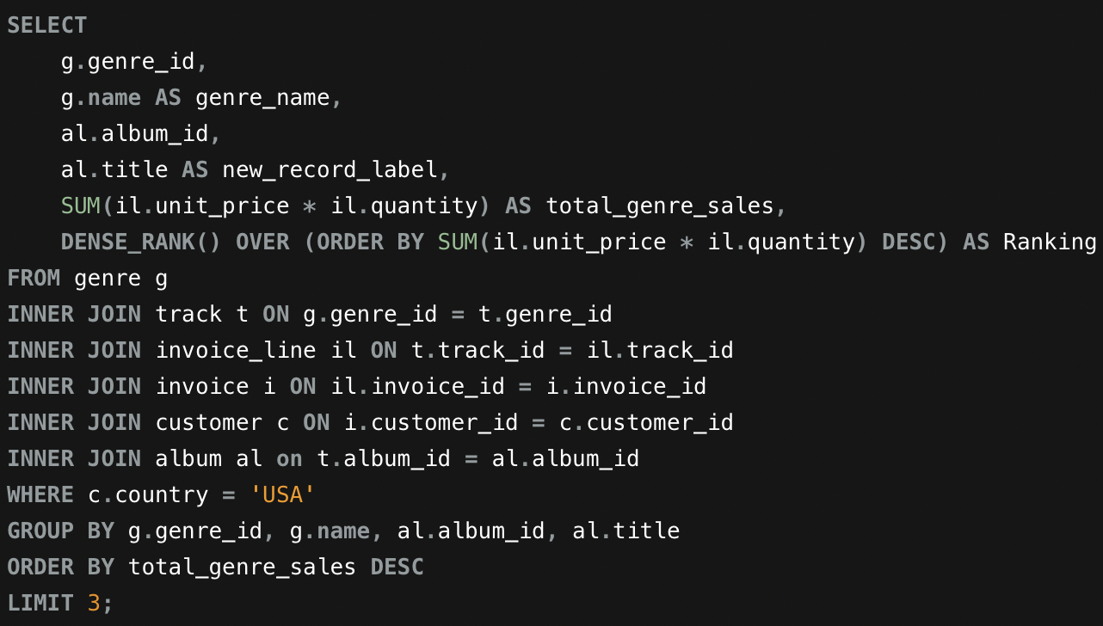

**Output Table:**

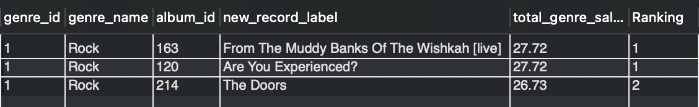

**Recommendation:**

Based on my analysis following are 3 albums that should be prioritized for advertising and promotion in USA:

1. ***From The Muddy Banks Of The Wishkah [Live]***
2. ***Are You Experienced?***
3. ***The Doors.***

**Insights:**

* **Genre Popularity**: Rock is the most promising genre with the highest total sales figures. The top three albums all belong to this genre, indicating a strong market preference for Rock music in the USA.
* **Sales Figures**: The selected albums have the highest total genre sales, making them strong candidates for promotion.

**Visualisation:**

Given the strong sales performance of these albums in the Rock genre, they should be prioritized for advertising and promotion in the USA to capitalize on their popularity.

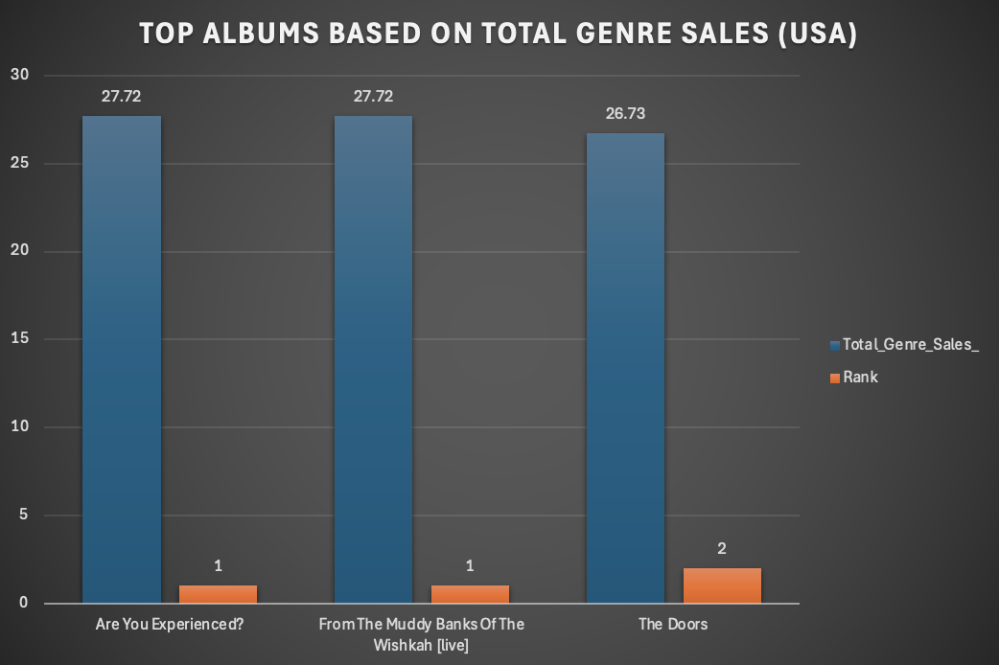

**2. Determine the top-selling genres in countries other than the USA and identify any commonalities or differences.**

Answer :-

**Approach:**

* Excluded USA transactions to focus the analysis on international markets only.
* Joined invoice, invoice line, track, and genre tables to link sales data with genre information.
* Calculated total sales for each genre by summing unit price multiplied by quantity.
* Aggregated results at the country and genre level to enable cross-country comparison.
* Ranked genres within each country based on total sales to identify top-performing genres.
* Analysed the ranked results to observe similarities and differences in genre preferences across countries.

**Query for the Analysis:**

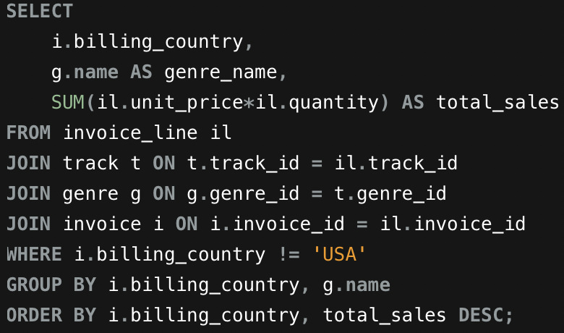

**Output Table:**

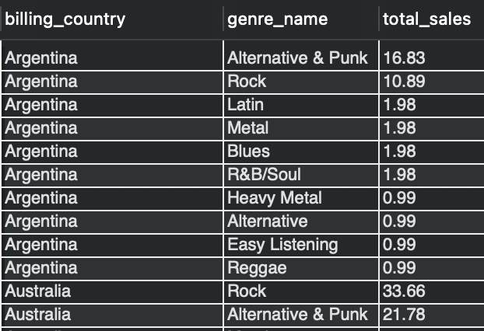

**Visualisation:**

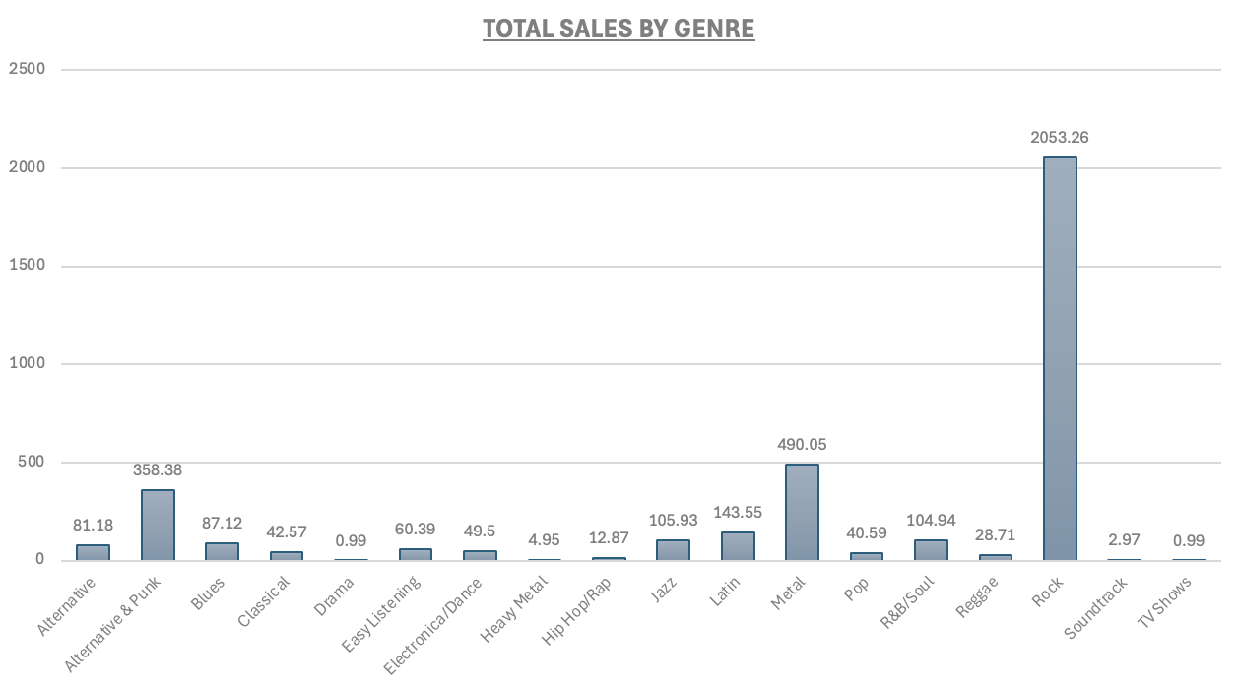

**Insights:**

**Similarities:**

* Rock, Metal, and Alternative & Punk emerge as the top-performing genres across both the USA and international markets.
* Rock is the most dominant genre in both regions, consistently generating the highest sales by a significant margin.
* Several genres show strong performance globally, including Latin, Jazz, R&B/Soul, and Blues, indicating broad international appeal.

**Differences:**

* Metal is the second highest-selling genre in countries outside the USA, whereas Alternative & Punk holds the second position within the USA.
* Genres such as R&B/Soul and Blues perform relatively better in the USA, suggesting stronger domestic preference.
* In contrast, Latin and Jazz record higher sales outside the USA, reflecting regional or cultural influences in international markets.
* Hip Hop appears among the top-selling genres in the USA but does not rank within the top genres outside the USA.

**Recommendation:**

* Prioritize global promotion of Rock, Metal, and Alternative & Punk genres, as they consistently perform well across both the USA and international markets and contribute significantly to overall revenue.
* Design unified marketing campaigns for these genres to leverage their widespread popularity and ensure consistent brand messaging across regions.
* Increase promotional focus on Latin and Jazz genres in non-USA markets, where these genres show stronger relative sales performance.
* Use region-specific advertising, curated playlists, and localized campaigns for Latin and Jazz to better align with international customer preferences and drive higher engagement.

**3. Customer Purchasing Behaviour Analysis: How do the purchasing habits (frequency, basket size, spending amount) of long-term customers differ from those of new customers? What insights can these patterns provide about customer loyalty and retention strategies?**

Answer :-

**Approach:**

* Joined customer, invoice, and invoice line tables to capture complete customer purchase behaviour.
* Calculated tenure, purchase frequency, average basket size, and average spending for each customer.
* Segmented customers into **Long Term** and **New** based on purchase tenure.
* Compared key metrics across segments to understand differences in purchasing behaviour and loyalty patterns.

**Query for the Analysis:**

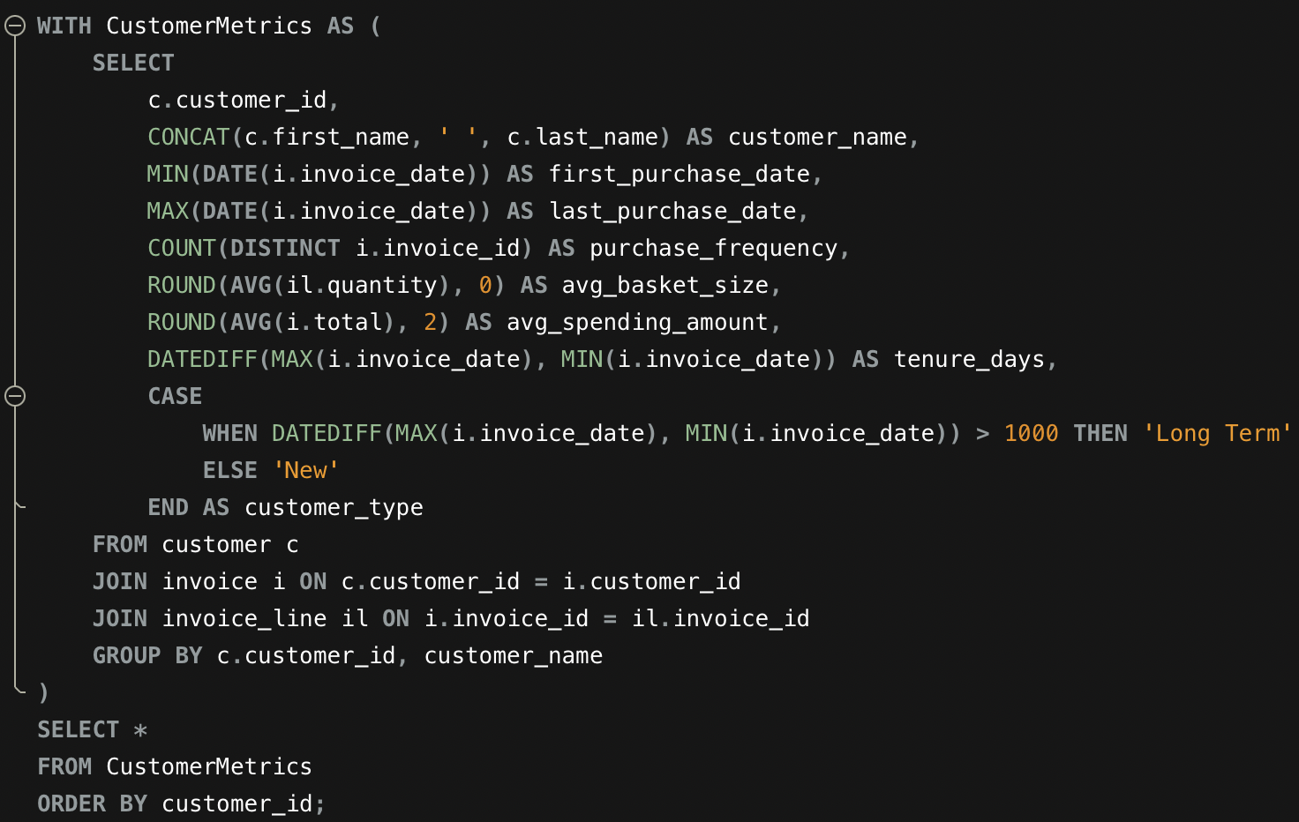

**Output Table:**

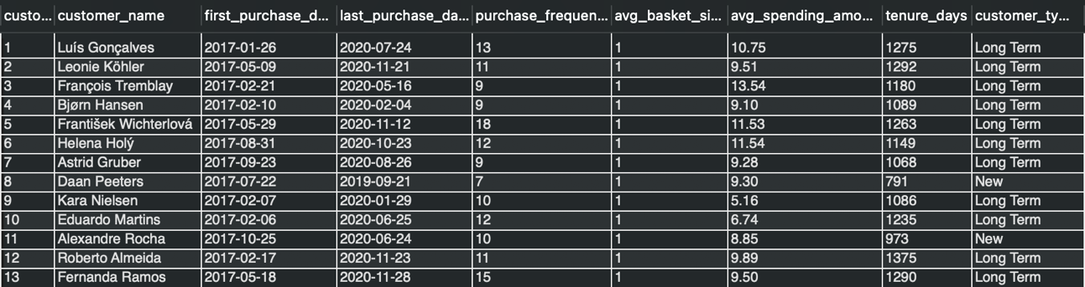

**Visualisation:**

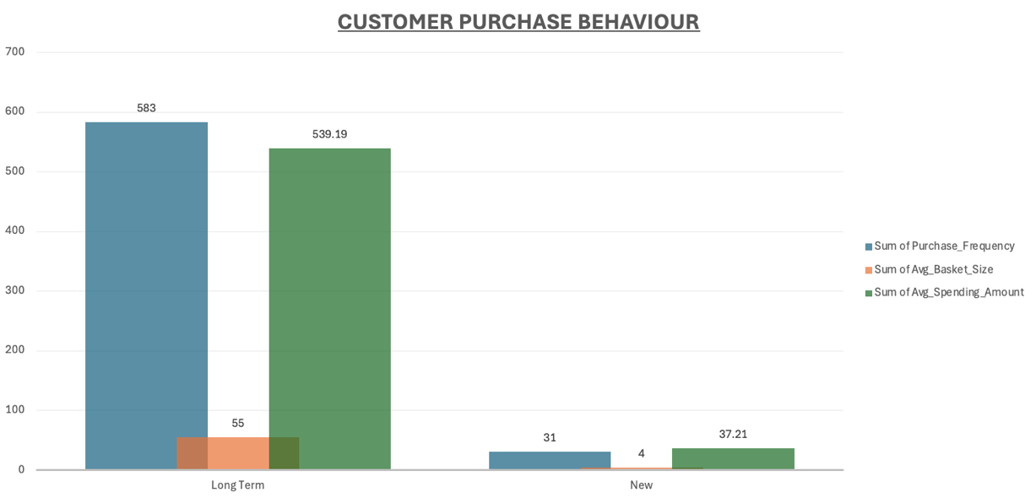

**Insights:**

* Long-term customers demonstrate higher purchase frequency and contribute significantly more to overall revenue, indicating strong engagement with the platform.
* New customers tend to purchase less frequently and spend smaller amounts, suggesting they are still in the early stages of exploring the product catalogue.
* The majority of customers maintain a basket size of one, which indicates a preference for purchasing individual tracks rather than multiple items per transaction.
* The purchasing patterns of long-term customers reflect higher loyalty and consistent buying behaviour, while new customers represent an opportunity for targeted strategies to encourage repeat purchases and increased engagement.

**Recommendation:**

* Reward long-term customers with loyalty benefits to sustain engagement and repeat purchases.
* Use personalized promotions to encourage new customers to buy more frequently.
* Introduce bundle and cross-sell offers to increase average basket size.
* Track customer tenure to identify at-risk customers and run timely retention campaigns.

1. **Product Affinity Analysis: Which music genres, artists, or albums are frequently purchased together by customers? How can this information guide product recommendations and cross-selling initiatives?**

Answer :-

**Approach:**

* Used the invoice_line table to identify tracks that were purchased together within the same invoice.
* Joined track, album, artist, and genre tables to map each purchased track to its corresponding album, artist, and genre.
* Analysed purchase affinity at three levels: genre-to-genre, artist-to-artist, and album-to-album combinations.
* Counted how frequently each pair of genres, artists, or albums appeared together using aggregation functions.
* Ranked the pairs by using ORDER BY times_bought_together DESC LIMIT 10 to bring back the top results.

**(a) Frequently Purchased Genres Together**

**Query for the Analysis:**

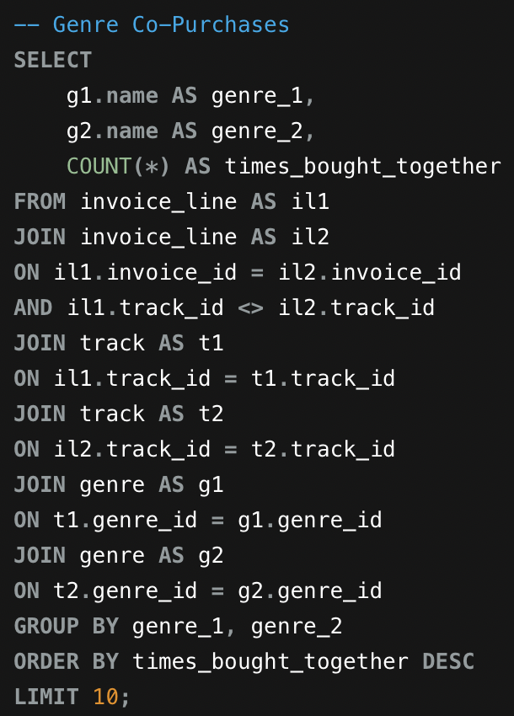

**Output Table:**

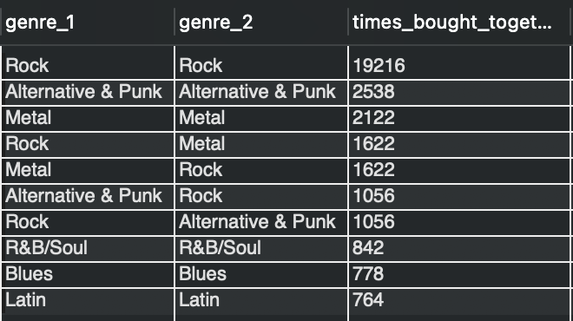

**Visualisation:**

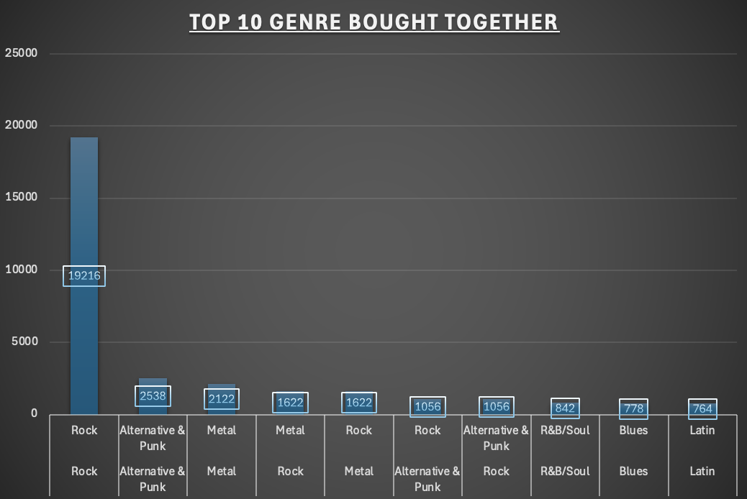

**(b) Frequently Purchased Artist Together**

**Query for the Analysis:**

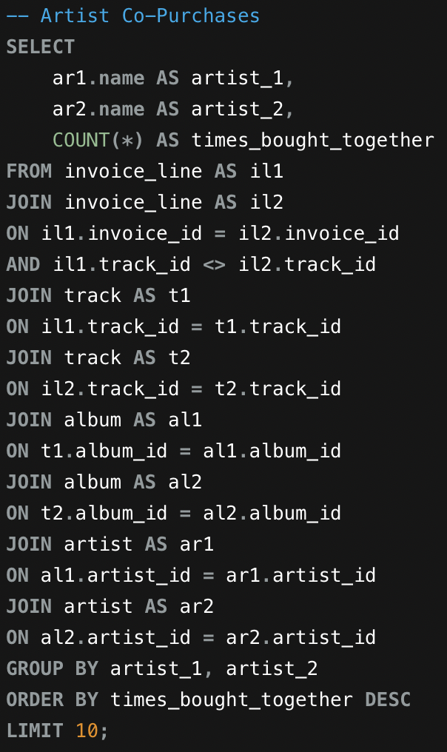

**Output Table:**

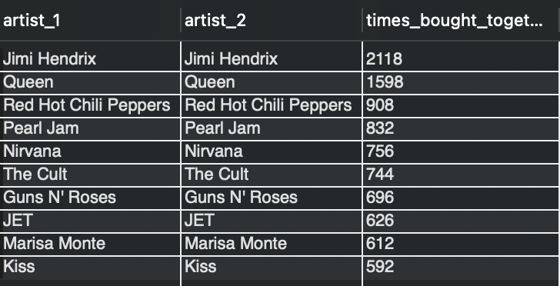

**Visualisation:**

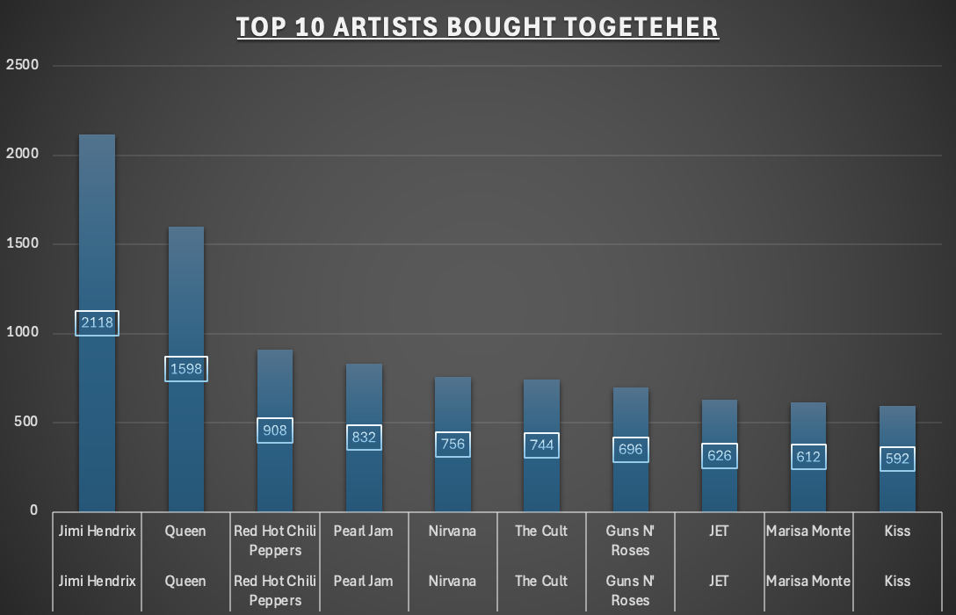

**(c) Frequently Purchased Album Together**

**Query for the Analysis:**

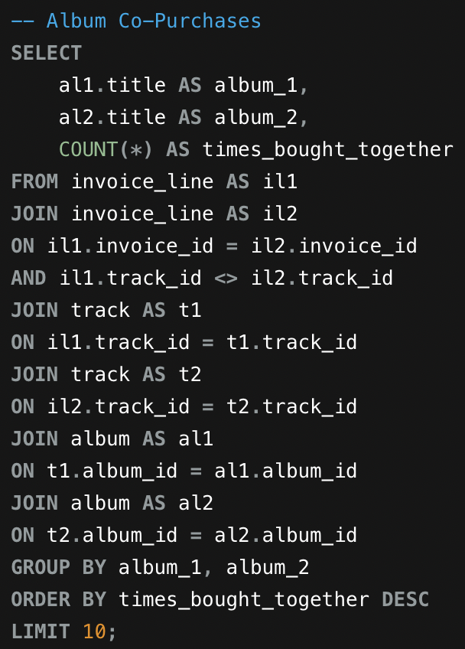

**Output Table:**

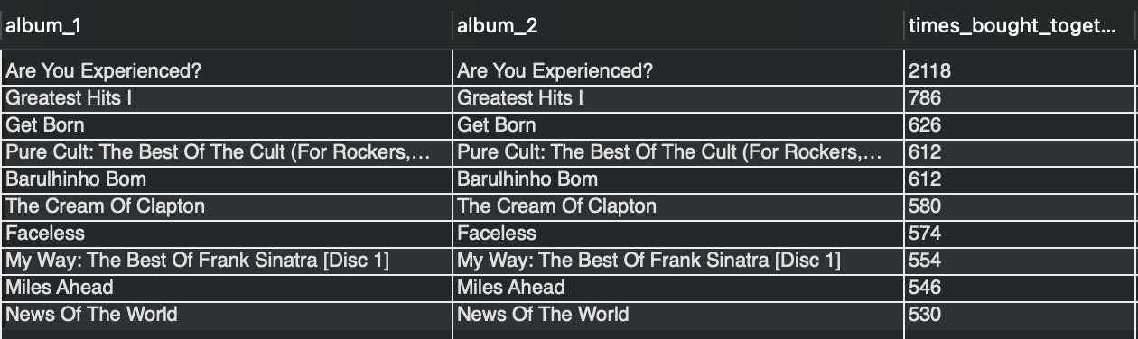

**Visualisation:**

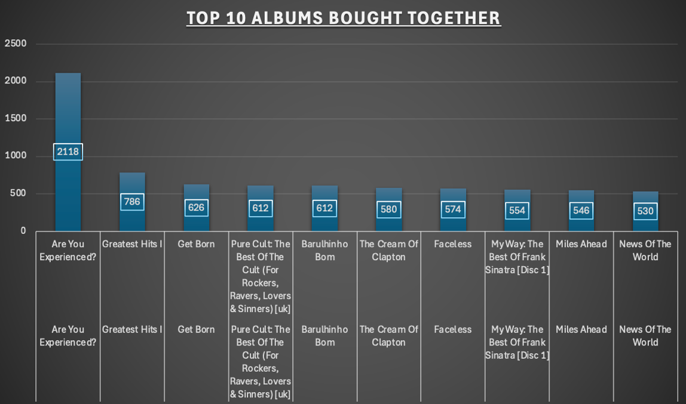

**Insights:**

Product Affinity Analysis

* Purchases involving **Rock tracks together** are by far the most common, indicating a strong tendency for customers to buy multiple Rock tracks in the same transaction.
* **Metal** and **Alternative & Punk** also show notable self-pairing behaviour, although their co-purchase frequency is lower compared to Rock.
* Rock frequently appears alongside **Alternative & Punk** and **Metal**, suggesting meaningful cross-genre overlap and shared listener preferences.
* At the artist and album level, most co-purchases occur within the **same artist or the same album**, indicating that customers often complete collections or explore multiple tracks from artists they already like.

**Recommendations:**

Product Affinity Analysis

* Promote Rock-focused bundles and recommendations to maximize cross-selling opportunities.
* Encourage Metal and Alternative & Punk fans with same-genre track suggestions and targeted offers.
* Create cross-genre promotions combining Rock with Alternative & Punk or Metal to leverage listener overlap.
* Recommend full albums or related releases when customers purchase multiple tracks from the same artist or album.

**5. Regional Market Analysis: Do customer purchasing behaviours and churn rates vary across different geographic regions or store locations? How might these correlate with local demographic or economic factors?**

Answer :-

**Approach:**

Analysed customer behaviour by country using two queries:

* **Query 1** calculated core transactional metrics: total customers, orders, revenue, average order value, and purchase frequency to assess market performance and engagement levels.
* **Query 2** measured churn rate by identifying customers with no purchases in the last 6 months, providing insights into customer retention across different geographic markets.

**Query for the Analysis:**

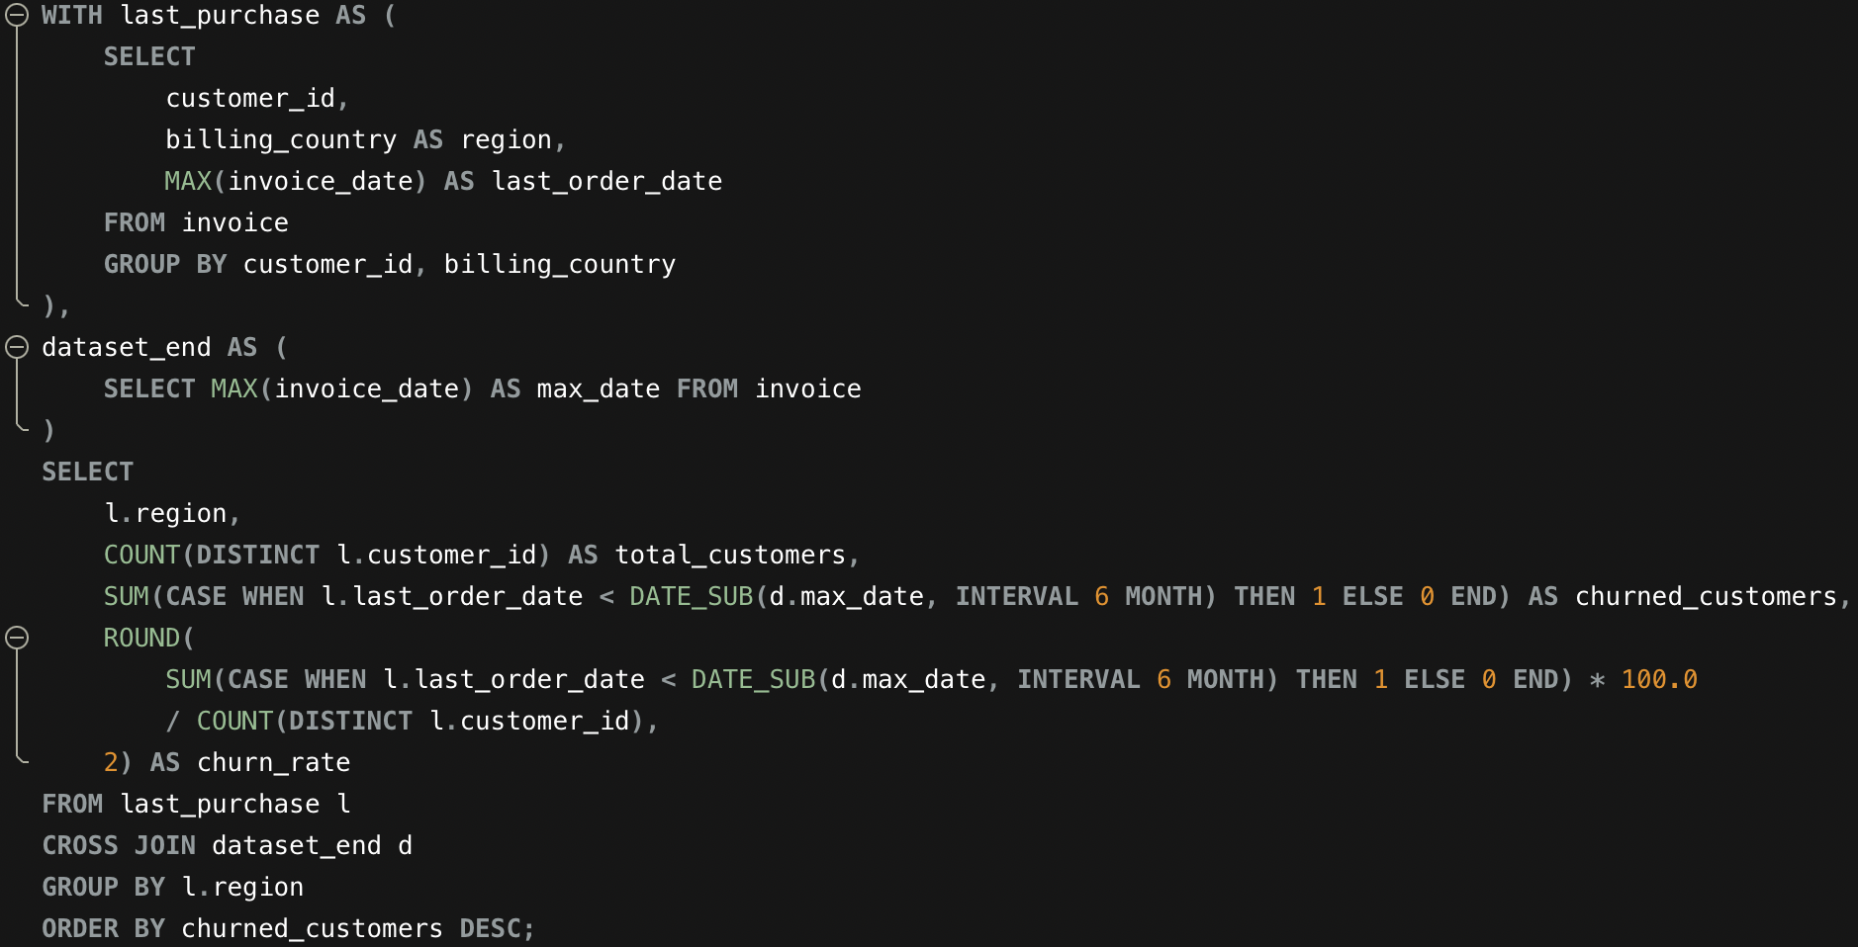

**Output Table:**

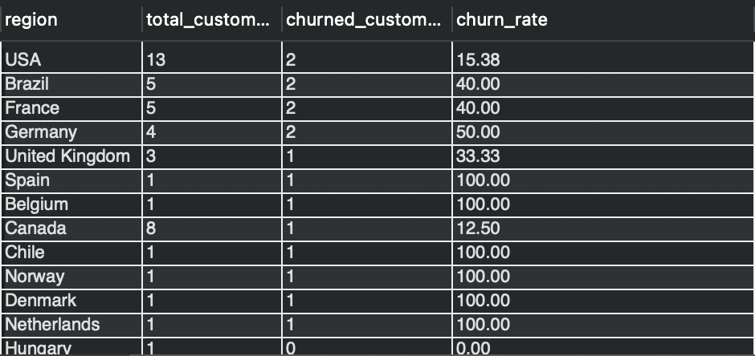

**Visualisation:**

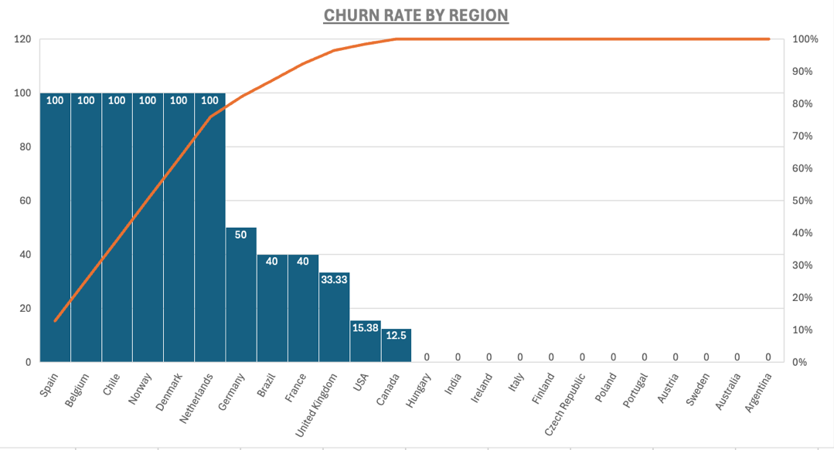

**Insights:**

**Top Market Performance**

* USA dominates with highest customers, orders, and revenue, driven by strong rock music demand and market size.
* Canada ranks second across all metrics, benefiting from English-language alignment and developed economy strength..

**High-Value Customer Segments**

* Czech Republic leads in customer value with 9.11 average order value and 15 orders per customer, signalling premium spending power.
* This market presents significant opportunity for high-margin product expansion.

**Retention Strengths in Core Markets**

* USA maintains strong 84.62% retention rate despite large customer base, demonstrating solid customer satisfaction..
* Canada excels with 87.50% retention rate, indicating exceptional loyalty and market fit

**Retention Challenges & Opportunities**

* Germany shows critical 50% churn requiring immediate retention intervention (2 of 4 customers lost).
* France and Brazil each face 40% churn, likely due to language barriers or content misalignment with local preferences..
* These underperforming markets offer clear targets for localized campaigns and customer win-back strategies.

Note: Churned customers = customers whose last purchase was more than 6 months before the latest purchase date in the dataset.

**Recommendations:**

* Focus on **customer acquisition** in countries with only one customer through referrals and introductory promotions.
* Prioritize **customer retention** in high-churn markets (Germany, Brazil, France) using targeted offers and localized, genre-focused marketing.
* In strong markets like the USA and Canada, **increase customer lifetime value** through cross-selling Rock and closely related genres

**6. Customer Risk Profiling: Based on customer profiles (age, gender, location, purchase history), which customer segments are more likely to churn or pose a higher risk of reduced spending? What factors contribute to this risk?**

Answer :-

**Approach:**

* Built a customer-level dataset by computing **purchase frequency, total revenue contribution, most recent transaction date, and customer inactivity period** using invoice and invoice line data.
* Categorized customers into **High, Medium, and Low churn-risk groups** based on the length of time since their last purchase.
* Further classified customers into **Low, Medium, and High value segments** according to their overall spending.
* Integrated churn-risk and value classifications to highlight **customers with high churn likelihood and low or declining revenue potential**.

**Query for the Analysis:**

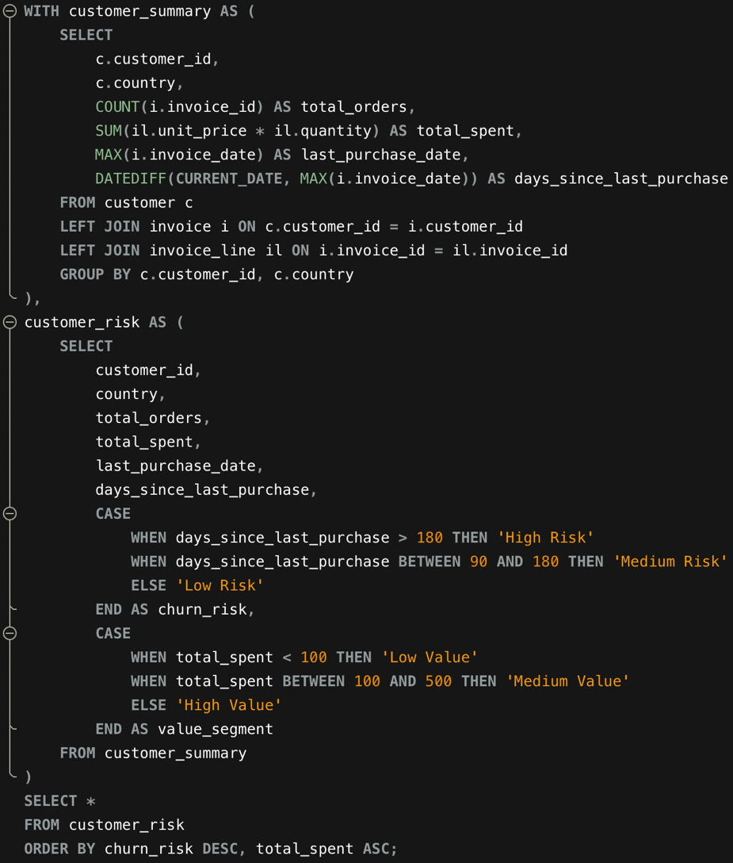

**Output Table:**

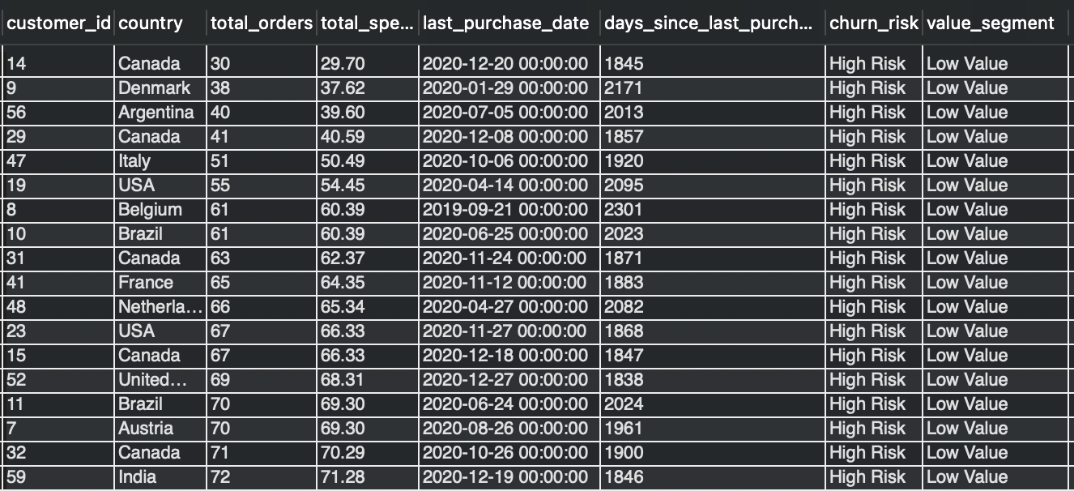

**Visualisation:**

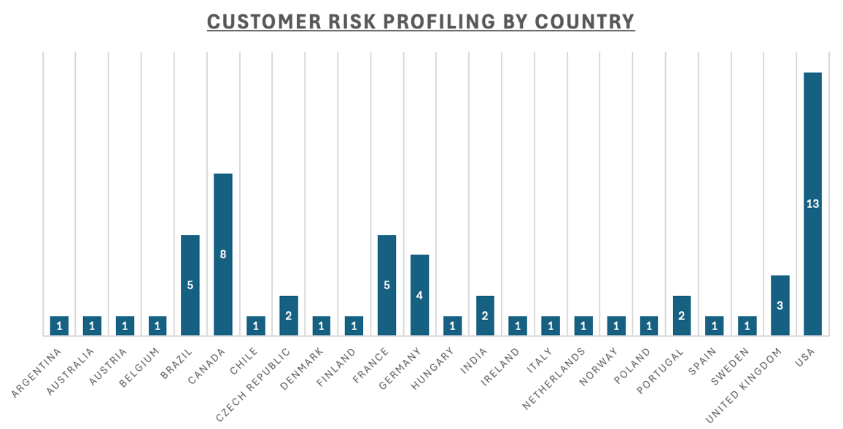

**Insights:**

* A significant proportion of customers fall into the **High-Risk segment**, primarily due to extended inactivity, with many customers having **not made a purchase for over 1,700 days**.
* Several customers exhibit **high purchase frequency but low overall value**, suggesting **low average spend per order**.
* Countries such as **Canada, Denmark, Argentina, Italy, the USA, and Belgium** show a higher concentration of **high-risk, low-value customers**, indicating limited engagement and revenue contribution from these regions.

**Recommendations:**

* Implement **re-engagement initiatives** for inactive customers using personalized offers and targeted communication.
* Strengthen **customer loyalty mechanisms** by incentivizing repeat purchases through rewards and exclusive benefits.
* Analyse **purchase behaviour inefficiencies** to understand why frequent buyers generate limited revenue.
* Enhance customer profiling by **integrating additional demographic informations** for more accurate risk assessment.

**7. Customer Lifetime Value Modelling: How can you leverage customer data (tenure, purchase history, engagement) to predict the lifetime value of different customer segments? This could inform targeted marketing and loyalty program strategies. Can you observe any common characteristics or purchase patterns among customers who have stopped purchasing?**

Answer :-

**Approach:**

**1. Prepare customer-level metrics:**

* Derived key indicators such as total amount spent, number of purchases, average spend per order, customer lifetime, and time since last purchase.
* These metrics were used to evaluate customer value and identify churn behavior.

**2. Group customers by activity level:**

* **Active customers:** Made a purchase in the last 30 days
* **At-risk customers:** Last purchase between 31 and 180 days ago
* **Churned customers:** No purchases in the past 180 days

**3. Estimate Customer Lifetime Value (CLV):**

* Calculated daily revenue contribution from past transactions and projected the expected value for the next one year.

**4. Identify trends among churned customers:**

* Analysed customer location, purchase frequency, and length of relationship to detect common churn-related patterns.

**Query for the Analysis:**

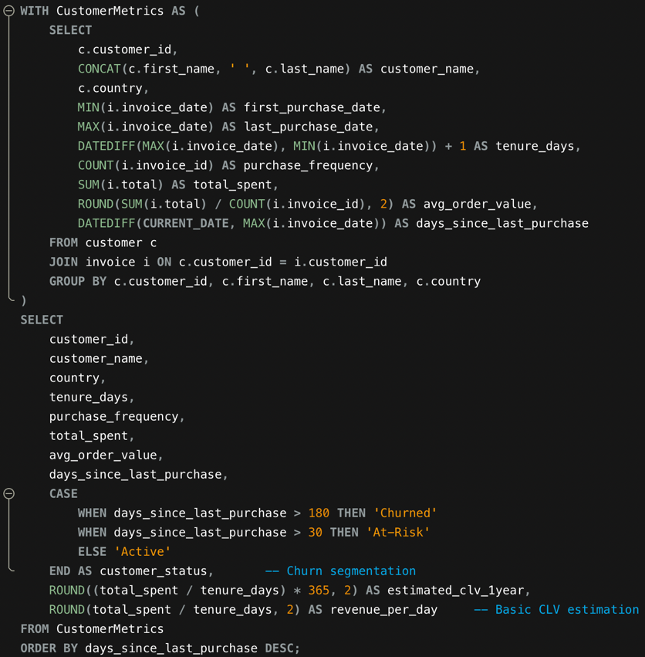

**Output Table:**

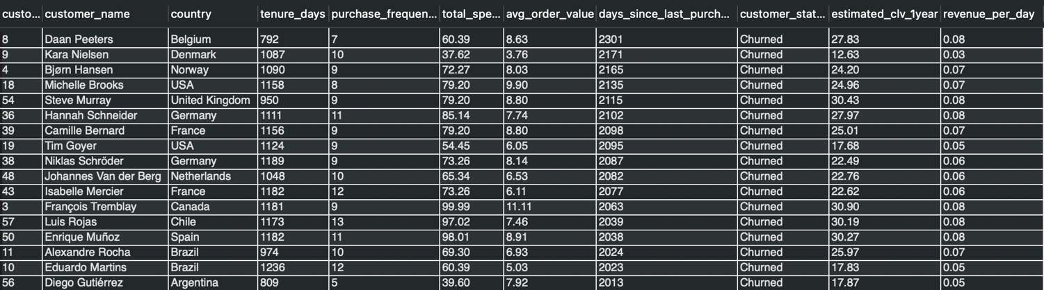

**Visualisation:**

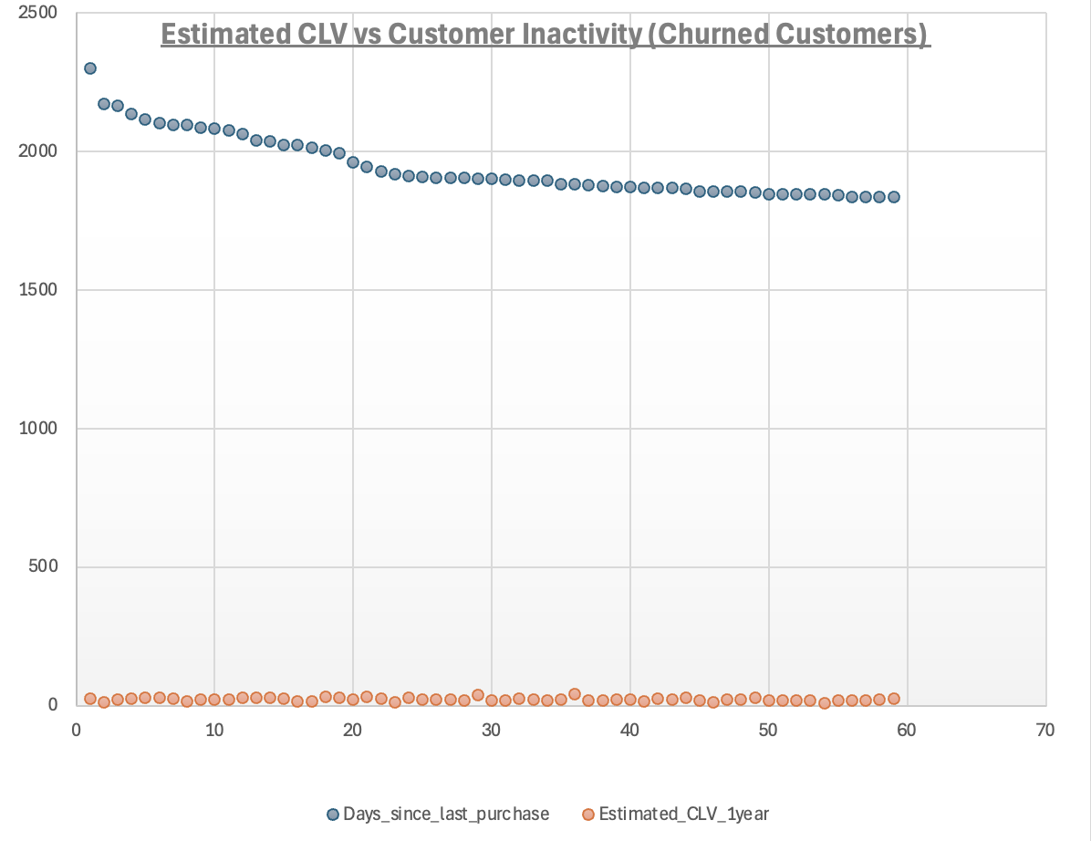

**Insights:**

* Customers who purchase often and spend more overall show the **highest estimated lifetime value**, making them the most valuable segment.
* Customers identified as **churned** generally share common traits:
  + A long time has passed since their last purchase.
  + Higher representation from certain countries.
  + Fewer purchases and shorter customer lifespans.
* Customers who are new but already purchasing frequently present a strong **opportunity for long-term retention** if engaged early.

**Recommendations:**

* Retain top-spending customers by providing exclusive benefits such as rewards, special offers, or early access to new content.
* Reconnect inactive or at-risk customers through personalized discounts and targeted re-engagement campaigns.
* Prioritize retention efforts in regions and customer groups that show higher churn risk.
* Identify new customers with strong early purchase behaviour and engage them quickly to build long-term loyalty.
* Use past purchase patterns to suggest relevant products or genres and improve cross-selling effectiveness.

**8. If data on promotional campaigns (discounts, events, email marketing) is available, how could you measure their impact on customer acquisition, retention, and overall sales?**

Answer :-

If promotional campaign data were available, the impact on customer acquisition, retention, and overall sales could be evaluated using the following structured approach:

**a) Identify Promotional Periods**

* Use promotion-related fields or tables to determine the exact time periods when discounts, campaigns, or marketing events were active.

**b) Segment the Data**

* Divide the dataset into **promotional periods** and **non-promotional periods** to enable comparison.

**c) Customer Acquisition Analysis**

* Compare the number of **new customers acquired** during promotional periods against non-promotional periods.

**d) Customer Retention Analysis**

* Evaluate retention by measuring **repeat purchases** and continued engagement during and after promotional periods.

**e) Sales Performance Evaluation**

* Analyse changes in **total revenue, average order value, and basket size** between promotional and non-promotional periods.

**9. How would you approach this problem, if the objective and subjective questions weren't given?**

Answer :-

When specific questions are not provided, the problem can be addressed through a **data-driven, exploratory workflow** that gradually uncovers business insights from the available dataset.

1. **Knowing The Data** 
   * Review the database structure to understand key tables, relationships, and business entities such as customers, transactions, and products.
   * Identify core business indicators including revenue, customer behaviour, and geographic attributes.
2. **Data Validation and Preparation**
   * Examine the dataset for inconsistencies, missing values, or duplicate records.
   * Apply appropriate cleaning techniques to ensure data reliability and accuracy.
3. **Revenue and Sales Trend Analysis**
   * Evaluate overall sales trends, average transaction value, and top-performing products across different time periods and locations.
4. **Customer Behaviour Analysis**
   * Study customer demographics and purchasing patterns to build meaningful customer segments.
   * Assess customer retention, churn behaviour, and estimate customer lifetime value.
5. **Geographic and Market Evaluation**
   * Compare performance across regions and analyse how location-related factors influence sales and customer engagement.
6. **Product Association Analysis**
   * Identify commonly purchased product combinations to support cross-selling and recommendation strategies.
7. **Promotion Effectiveness Assessment**
   * Analyse how marketing campaigns or promotional activities influence customer acquisition, retention, and sales performance.
8. **Insight Generation and Strategic Recommendations**
   * Translate analytical findings into actionable recommendations focused on growth, pricing optimization, and targeted marketing.
9. **Reporting and Communication**
   * Present insights using clear visualizations and concise summaries to support decision-making.

**Conclusion**

This methodology relies on continuous exploration and analysis of data to extract meaningful insights. By iteratively refining findings, the approach supports informed strategic decisions aimed at improving customer retention, increasing revenue, and identifying long-term growth opportunities.

**10. How can you alter the "Albums" table to add a new column named "Release Year" of type INTEGER to store the release year of each album?**

Answer :-

**Approach:**

To add a new column named "ReleaseYear" of type INTEGER to store the release year of each album we can use "Alter" command

**Query**:

 

**Output**:

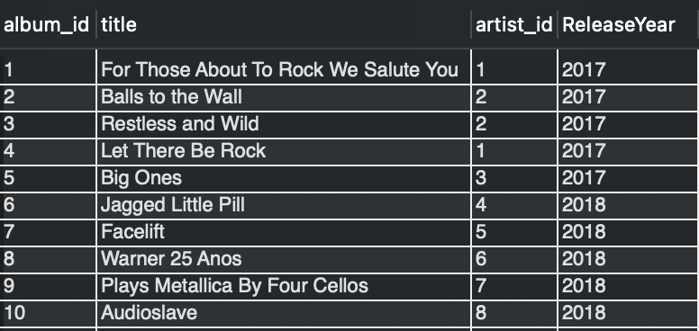

**11. Chinook is interested in understanding the purchasing behaviour of customers based on their geographical location. They want to know the average total amount spent by customers from each country, along with the number of customers and the average number of tracks purchased per customer. Write an SQL query to provide this information.**

Answer :-

**Approach:**

* Calculated the total number of tracks purchased by each customer using invoice and invoice line data.
* Computed total spending for each customer and linked it with their country information.
* Aggregated customer-level data by country to determine the **number of customers**, **average spending per customer**, and **average tracks purchased per customer**.
* Sorted results to identify countries with higher average customer spending.

**Query for the Analysis:**

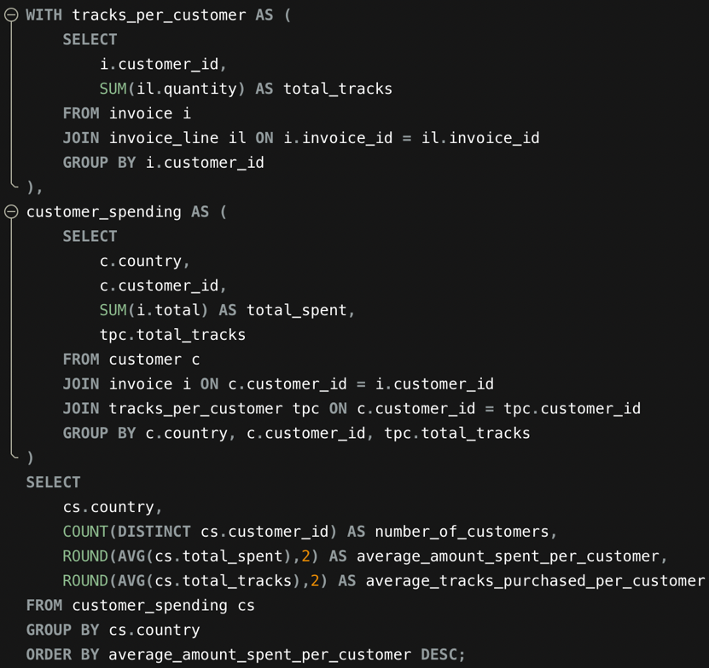

**Output Table:**

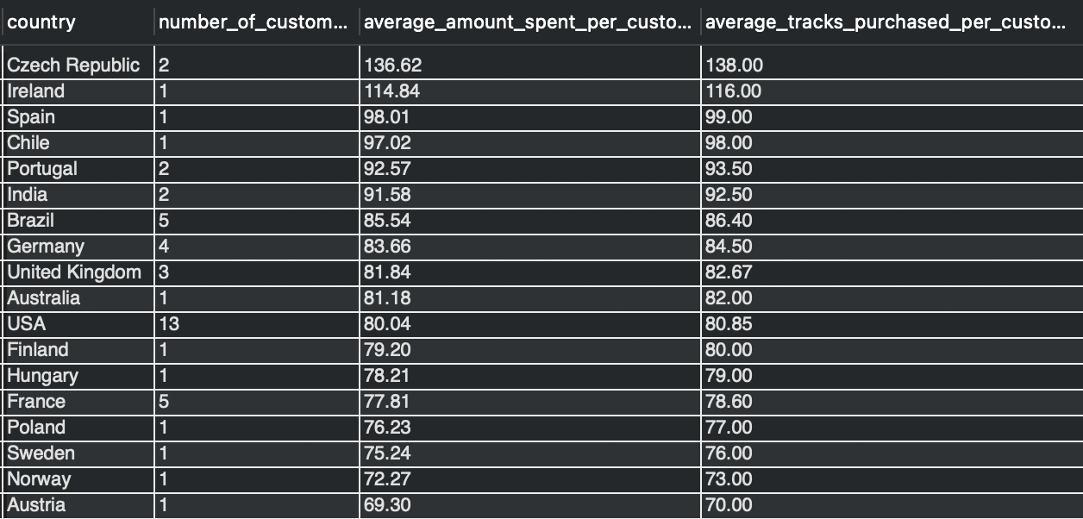

**Visualisation:**

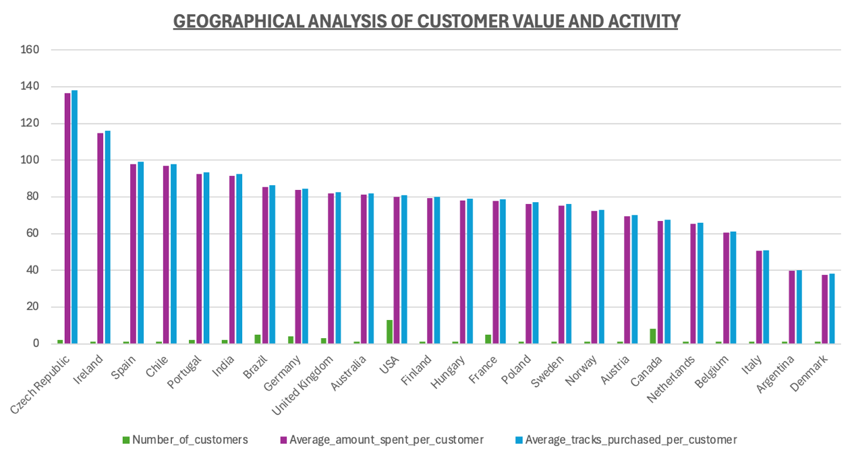

**Insights:**

* The **Czech Republic** shows the highest average spending per customer, indicating strong revenue contribution from individual customers in this region.
* The **USA** has the largest number of customers, but a comparatively lower average spend, suggesting wider reach with lower spend per customer.
* Customers from **India, Portugal, and Brazil** demonstrate moderate spending levels, with differences driven by varying customer counts.
* **Argentina and Denmark** record the lowest average customer spending, pointing to limited purchasing activity.
* Countries with only a single customer, such as **Ireland and Spain**, display relatively high average spending, emphasizing the impact of individual high-value customers.

**Recommendations:**

* Target High-Value Markets**:** To concentrate our efforts on acquiring new customers in nations with high levels of spending (such as the Czech Republic and Ireland).
* Customize Promotions: To increase per-customer value, provide track-focused offers in nations like India and upsell or promote in high-volume markets like the USA.
* Customize approaches to take advantage of the distinct purchasing patterns of each area.

--------------------------------------------------------THE END-------------------------------------------------------------